(F __- ___)
MINISTRY OF EDUCATION AND SCIENCE OF UKRAINE
National Aviation University
Educational and Scientific Law Institute

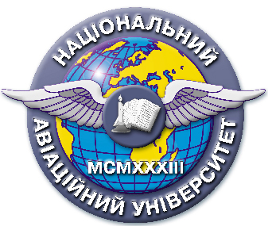

Quality Management System
EDUCATIONAL AND METHODICAL COMPLEX
educational discipline

«Advocacy and Notary Service in Ukraine»

Field of Study: 08 “Law”

Specialty: 081 “Law”
Education Professional Program: “Jurisprudence”

QMS NAU 13.01.03-01-2018

KIEV

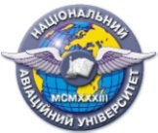 | Quality management system  EDUCATIONAL AND METHODICAL COMPLEX  educational discipline  « Advocacy and Notary Service in Ukraine » | Document Code | QMS NAU CTP  09.01.06-01-2018
 |  | P. 2 of 2

Developed by
Associated Professor of the Department of
Criminal Law and Process I. Litvinova
Senior Lector of the Department of
Criminal Law and Process N. Semchuk

Discussed and approved by the Department of Criminal Law and Process, Minutes № _______of " " 2018.
Head of the Department S. Likhova

