MINISTRY OF EDUCATION AND SCIENCE OF UKRAINE
NATIONAL AVIATION UNIVERSITY
FACULTY OF AIR NAVIGATION, ELECTRONICS AND TELECOMMUNICATIONS
AIR NAVIGATION SYSTEMS DEPARTMENT

PERMISSION FOR DEFENCE

Head of the Department
Doctor of Sciences (Engineering), prof.
___________V.Yu. Larin
"_____" ______ 2020

MASTER’S THESIS
ON THE EDUCATIONAL PROFESSIONAL PROGRAM
"AIR TRAFFIC SERVICE"
(EXPLANOTARY NOTE)
Theme: «Optimization and increase of passenger flow in Boryspil International Airport»

Performed by: V.O. Priadko
Supervisor: Associated prof. M.M. Bogunenko

Standard Inspector: T.F. Shmelova

KYIV 2020
МІНІСТЕРСТВО ОСВІТИ І НАУКИ УКРАЇНИ
Національний авіаційний університет
ФАКУЛЬТЕТ Аеронавігації, електроніки та телекомунікацій
Кафедра аеронавігаційних систем

ДОПУСТИТИ ДО ЗАХИСТУ
Завідувач кафедри
д-р техн. наук, проф.
В.Ю. Ларін
« » 2020 р.

ДИПЛОМНА РОБОТА
(ПОЯСНЮВАЛЬНА ЗАПИСКА)
випускницы ОСВІТНЬОГО СТУПЕНЯ МАГІСТРА
За освітньо-професійною програмою
«обслуговування повітряного руху»

Тема: «Оптимізація та збільшення пасажиропотоку у Державному підприємстві Міжнародний Аеропорт «Бориспіль»
Виконавець: Прядко В.О.
Керівник: Богуненко М.М.

Нормоконтролер: Шмельова Т.Ф.

Київ 2020
NATIONAL AVIATION UNIVERSITY
FACULTY OF AIR NAVIGATION, ELECTRONICS AND TELECOMMUNICATIONS
AIR NAVIGATION DEPARTMENT

APPROVED BY
Head of the Department
V. Yu. Larin
«…» …………… 2019

Graduate Student’s Degree Thesis Assignment
Priadko Viktoriia
1. The Thesis topic: «Optimization and increase of passenger flow in Boryspil International Airport» approved by the Rector’s order of 29.10.2019 № 2524/st.
2. The Thesis to be completed between 14.10.2019 – 25.01.2020.
3. Initial data to the thesis (project): Doc 9652 ICAO, Resolution AHM-810 IATA, Air Code.
4. The content of the explanatory note (the list of problems to be considered): study and analysis of the characteristics affecting the passenger flow at Boryspil International Airport, recommendations for their improvement.
5. The list of mandatory graphic (illustrated) materials: 19 figures of explanatory material, 4 tables, 3 formulas.

6. Calendar timetable
№ | Completion stages of Degree Thesis | Stage completion dates | Remarks
1. | Preparation of Chapter 1: «Worldwide requirements to passenger service organization» | 14.10.19-05.11.19 | complete
2. | Preparation of Chapter 2: «Ukrainian requirements for passenger service» | 06.11.19-20.11.19 | complete
3. | Preparation of Chapter 3: «Analysis of passenger service at Boryspil International Airport» | 21.11.19-10.12.19 | complete
4. | Preparation of chapter 4: «Effective way to improve passenger flow» | 10.12.19-10.01.20 | complete
5. | Preparation of report and graphic materials | 10.01.20 -25.01.20 | complete
7. Date of issue: 10.10.2019
Supervisor of graduate work __________________________ Bogunenko M.M.
(signature) (name, surname)
The task is obtained for fulfillment by_______________________Priadko V.O
(signature) (name, surname)
НАЦІОНАЛЬНИЙ АВІАЦІЙНИЙ УНІВЕРСИТЕТ
ФАКУЛЬТЕТ АЕРОНАВІГАЦІЇ, ЕЛЕКТРОНІКИ ТА ТЕЛЕКОМУНІКАЦІЙ
КАФЕДРА АЕРОНАВІГАЦІЙНИХ СИСТЕМ
СПЕЦІАЛЬНІСТЬ 272 «АВІАЦІЙНИЙ ТРАНСПОРТ»

ЗАТВЕРДЖУЮ

Завідувач кафедри
Ларін В.Ю.
«…» …………... 2019 р.
ЗАВДАННЯ
на виконання дипломної роботи магістра
Прядко Вікторії Олексіївни
1. Тема дипломної роботи: «Оптимізація та збільшення пасажиропотоку у Державному підприємстві Міжнародний Аеропорт «Бориспіль» затверджена наказом ректора від 29.10.2019р. № 2524/ст
2. Термін виконання роботи : 14.10.2019 – 25.01.2020
3. Вихідні дані до роботи: Документ 9652 ICAO, Резолюція AHM-810 Міжнародної асоціації повітряного транспорту, Повітряний кодекс України.
4. Зміст пояснювальної записки: вивчення та аналіз характеристик, що вливають на пасажиропотік у міжнорадному аеропорті «Бориспіль», рекомендації щодо їх покращення.
5. Перелік обов'язкового графічного (ілюстративного) матеріалу: 19 даних пояснювальних матеріалів, 4 таблиці, 3 формули.
6. Календарний план-графік

№ пор. | Завдання | Термін виконання | Відмітка про виконання
1 | Підготовка та написання Розділу 1: «Світові вимоги до організації обслуговування пасажирів» | 14.10.19-05.11.19 | виконано
2 | Підготовка та написання Розділу 2: «Українські вимоги до обслуговування пасажирів» | 06.11.19-20.11.19 | виконано
3 | Підготовка та написання Розділу 3: «Аналіз обслуговування пасажирів в міжнародному аеропорті «Бориспіль» | 21.11.19-10.12.19 | виконано
4 | Підготовка та написання Розділу 4: «Ефективний спосіб поліпшити пасажиропотік» | 10.12.19-10.01.20 | виконано
5 | Підготовка презентації та доповіді | 10.01.20 -25.01.20 | виконано
7. Дата видачі завдання: 10.10.19
Керівник дипломної роботи ___________________ Богуненко М.М.
(підпис керівника) (П.І.Б.)
Завдання прийняв до виконання __________________Прядко В.О.
(підпис випускника) (П.І.Б.)
ABSTRACT
Explanatory note to a graduate work «Optimization and increase of passenger flow in Boryspil International Airport»: 94 pages, 19 figures, 4 tables, 21 references.
The aim of graduate work – provision of quality and efficient service, development of recommendations for increase and optimization of passenger traffic.
Means of improvement - analysis of existing procedures in passenger service, exploring ways to improve passenger traffic.
The object of improvement – Boryspil International Airport.
The subject of improvement – Passenger flow service.
Projection according the research object
The problem of passenger service is becoming more significant with the development of aviation. Passenger service plays an extremely important role in the operation of the airport, as poor interaction between different types of service can lead to disruption of the regularity of flights. As airlines, destinations, flights are getting larger, the airport needs to function properly - serving passengers quickly and efficiently. This issue is the most relevant for Boryspil International Airport, as it is central gates to Ukraine and more and more airlines are being served there.

PASSENGER TRAFFIC, PASSENGER SERVICE, AIRPORT, QUEUES MANAGEMENT, OPTIMIZATION, INCREASE, IMPROVEMENT
РЕФЕРАТ
Пояснювальна записка до дипломної роботи «Оптимізація та збільшення пасажиропотоку у Державному підприємстві Міжнародний Аеропорт «Бориспіль»: 94 сторінки, 19 рисунків, 4 таблиці, 21 використане джерело.
Мета дипломної роботи – надання якісного та ефективного обслуговування, розробка рекомедацій щодо збільшення та оптимізації пасажиропотоку.
Засоби досягнення – аналіз існуючих процедур в обслуговуванні пасажирів, вивчення шляхів для покращення пасажиропотоку.
Об’єкт удосконалення – Міжнародний аеропорт «Бориспіль».
Предмет удосконалення – обслуговування пасажиропотоку.
З розвитком авіації проблема пасажирського обслуговування стає дедалі актуальнішою. Пасажирське обслуговування відіграє надзвичайно важливу роль у функціонуванні аеропорту, так як неякісна взаємодія різних видів сервісу може призвести до порушень регулярності польотів. Так як авіакомпаній, напрямків, рейсів стає дедалі більше, аеропорт має функціонувати справно - обслуговувати пасажирів швидко та ефективно. Найбільш актуальна ця тема для аеропорту Бориспіль, так як саме він є наголовнішими воротами в Україну та все більше і більше авівкомпаній там обслуговуються.
ПАСАЖИРОПОТІК, ПАСАЖИРСЬКЕ ОБСЛУГОВУВАННЯ, АЕРОПОРТ, УПРАВЛІННЯ ЧЕРГАМИ, ОПТИМІЗАЦІЯ, ЗБІЛЬШЕННЯ, ПОКРАЩЕННЯ

LIST OF REMARKS

CONTENT
LIST OF ACRONYMS, TERMS…………………………………………………... 12
INTRODUCTION…………………………………………………………………...17
CHAPTER 1. WORLDWIDE REQUIREMENTS TO PASSENGER SERVICE ORGANISATION …………………………………………………………………..18
1.1 Legislation background for airport functioning based on ICAO Documents…...18
1.1.1 Doc 9652 ICAO – Airport Economics Manual………………………………..18
1.1.2. Doc 9137 ICAO - Airport Services Manual…………………………………..20
1.1.3 Doc 9626 ICAO - Manual on the Regulation of International Air Transport…23
1.1.4 Freedoms of the air…………………………………………………………… 25
1.1.5 Doc 9082 ICAO - Charges for Airports and Air Navigation Services………...28
1.1.6 Annex 14 ICAO –Aerodromes………………………………………………...36
1.2 Legislation background for airport functioning based on IATA documents…….37
1.2.1. IATA Resolution AHM-810 – Standard Ground Handling Agreement……....37
1.2.1 IATA Passenger Services Conference Resolutions Manual…………………...41
CONCLUSION TO CHAPTER 1…………………………………………………...48
CHAPTER 2. UKRAINIAN REQUIREMENT FOR PASSENGER SERVICE…...49
2.1 Airport as key element of infrastructure development in Ukraine………………49
2.2 Main local documents regarding airport activity………………………………...51
2.2.1 Air Code of Ukraine...………………………………………………………....51
2.2.2 Customs code of Ukraine…………………………………………….……......54
2.2.3 Law of Ukraine About Aviation Security Program of civil aviation……….…56
2.2.4 Law of Ukraine About Passport control………………………………...……..58
2.2.5 Order № 407 from the 13th of June 2006 by State Department on Aviation Security of Ukraine “About Approval of Rules of certification of airports” ……….59
2.2.6 Order № 636 from the 18th of December 2018 by the Ministry of Infrastructure of Ukraine “About Approval of Ownership Policy of State Enterprise "Boryspil International Airport”………………………………………………………………..61
CONCLUSION TO CHAPTER 2...…………………………………………………63
CHAPTER 3. ANALYSIS OF PASSENGER SERVICE AT BORYSPIL INTERNATIONAL AIRPORT………………………………………………….…..64
3.1 History of Boryspil International Airport…………………………...…………...64
3.2 Basics of work of Boryspil airport…………………………………………….....67
3.3 Calculation of passenger flow in Boryspil airport………………………….........73
CONCLUSION TO CHAPTER 3………………………………...…………………81
CHAPTER 4. EFFECTIVE WAY TO IMPROVE THE PASSENGER FLOW…....82
4.1. General information about Passenger Flow Measurement………………...……82
4.2. Main principles of Passenger Flow Measurement system………………………83
4.3 Advantages of PFM…………………………………………………………...…85
4.4 Limitations of Passenger Flow Management………..…………………..…….....87
CONCLUSION TO CHAPTER 4…………………………...………………………89
GENERAL CONCLUSION…………………………………………………………90
LIST OF REFERENCES……………………………………...…………………….92
APPENDIX A. Electronic ticket…………………...………………………………..94

LIST OF ACRONYMS, TERMS
ACM - Agency Credit Memos
ADM - Agent Debit Memo
ADT – Adult
BSP - Billing and Settlement Plan
CHD – Child
GDS - Global Distribution System
IATA - International Air Transport Association
ICAO - International Civil Aviation Organization
INF – Infant
INS – Infant with seat
MOU - Memorandum of Understanding
NVA – Not Valid After
NVB – Not Valid Before
PFM – Passenger Flow Management
PNR - Passenger Name Record
RFF – Rescue and Fire Fighting
QMS – Queue Measurement System
UNN - Unaccompanied Child
Aircraft. Any machine that can derive support in the atmosphere from the reactions of the air other than the reactions of the air against the earth’s surface.
Aircraft departures. The number of take-offs of aircraft. For statistical purposes, departures are equal to the number of landings made or flight stages flown.
Airport. Any area in a Contracting State which is open for commercial aircraft operations.
Baggage. Personal property of passengers or crew carried on an aircraft by agreement with the operator.
Cargo. Any property carried on an aircraft other than mail, stores and accompanied or mishandled baggage.
Code sharing. The use of the flight designator code of one air carrier on a service performed by a second air carrier, which service is usually also identified (and may be required to be identified) as a service of, and being performed by, the second air carrier.
Commercial air transport operator. An operator that, for remuneration, provides scheduled or non-scheduled air transport services to the public for the carriage of passengers, freight or mail. This category also includes small-scale operators, such as air taxis and commercial business operators, that provide commercial air transport services.
Crew member. A person assigned by an operator to duty on an aircraft during a flight duty period.
Distances. Aerodrome-to-aerodrome great circle distances should be used at least for international services, in all items involving distance computations. Distances can be calculated using the Great Circle Distance, defined as the shortest distance between any two points on the surface of the Earth, using the Vincenty distance formula associated with the World Geodesic System – 1984 (WGS 84) adopted by ICAO
Distance flown per passenger. The average distance flown per passenger is computed by dividing the passenger-kilometres by the related number of passengers carried.
Flight (air carrier operations). The operation of an aircraft on a flight stage or number of flight stages with the same flight number.
Flight coupon. Each component part of a ticket containing separate travel authority for subdivisions of the total travel covered by the passenger ticket.
Flight stage. A flight stage is the operation of an aircraft from take-off to its next landing. A flight stage is classified as either international or domestic based on the following definitions:
International. A flight stage with one or both terminals in the territory of a State, other than the State in which the air carrier has its principal place of business
Domestic. A flight stage not classifiable as international. Domestic flight stages include all flight stages flown between points within the domestic boundaries of a State by an air carrier whose principal place of business is in that State. Flight stages between a State and territories belonging to it, as well as any flight stages between two such territories, should be classified as domestic. This applies even though a stage may cross international waters or over the territory of another State.
Freedoms of the Air. A set of commercial aviation rights granting a country's airlines to overfly another country’s airspace and to land for a technical stop as well as the privilege pick-up and discharge traffic in another country's territory. Figure 1 shows in graphical forms the current Nine Freedoms of the Air.
International flight. A flight that contains one or more international flight stages.
Joint service flight. A flight identified by the designator codes of two air carriers that, with the concurrence of their respective States, typically have agreed with each other to share revenues and/or costs.
Leased aircraft. An aircraft used under a contractual leasing arrangement to increase an air carrier fleet capacity.
Low cost carrier. An air carrier that has a relatively low-cost structure in comparison with other comparable carriers and offers low fares and rates. Such an airline may be independent, the division or subsidiary of a major network airline or, in some instances, the ex-charter arm of an airline group.
Mail. All correspondence and other objects tendered by and intended for delivery to postal administrations.
Non-scheduled revenue flights (excluding on-demand flights). Charter flights and special flights performed for remuneration other than those reported under scheduled flights. They include any items related to blocked-off charters and exclude air taxi, commercial business aviation or other on demand revenue flights.
Operating carrier. That carrier whose flight number is being used for air traffic control purposes. For the purpose of reporting air carrier statistics to ICAO, all operational and traffic items should be reported by the operating carrier, including code-shared, franchised, pooled, blocked-off charter, blocked-space arrangements, joint services and leased aircraft services.
Passengers carried. The number of passengers carried is obtained by counting each passenger on a particular flight (with one flight number) once only and not repeatedly on each individual stage of that flight, with a single exception that a passenger flying on both the international and domestic stages of the same flight should be counted as both a domestic and an international passenger.
Passenger-kilometers performed. A passenger-kilometer is performed when a passenger is carried one kilometre. Calculation of passenger-kilometres equals the sum of the products obtained by multiplying the number of revenue passengers carried on each flight stage by the stage distance. The resultant figure is equal to the number of kilometres travelled by all passengers.
Revenue traffic. Traffic (passenger, freight or mail) flown by an air carrier for which it receives commercial remuneration. Unless otherwise stated, traffic data shown for air carriers generally correspond to revenue traffic, which can then be readily compared with the revenues reported for that traffic.
Seat-kilometres available. A seat-kilometre is available when a seat is flown one kilometre. Seat-kilometres available are equal to the sum of the products obtained by multiplying the number of passenger seats available for sale on each flight stage by the stage distance. It excludes seats not available for the carriage of passengers because of the extra mass of fuel required or other payload restrictions (see also payload capacity).
Scheduled revenue flights. Flights scheduled and performed for remuneration according to a published timetable, or so regular or frequent as to constitute a recognizably systematic series, which are open to direct booking by members of the public; and extra section flights occasioned by overflow traffic from scheduled flights.
Person with disabilities (with reduced mobility). Any person whose mobility is reduced due to a physical incapacity (sensory or locomotor), an intellectual deficiency, age, illness or any other cause of disability when using transport and whose situation needs special attention and the adaptation to the person’s needs of the services made available to all passengers.
Pilot-in-command. The pilot responsible for the operation and safety of the aircraft during flight time.
Security. Safeguarding civil aviation against acts of unlawful interference. This objective is achieved by a combination of measures and human and material resources.
Security control. A means by which the introduction of weapons, explosives or other dangerous devices, articles or substances which may be used to commit an act of unlawful interference can be prevented.
Stage distance flown per aircraft. The average stage distance flown per aircraft is obtained by dividing the aircraft kilometres flown by the related number of aircraft departures.
Technical stop. A stop most commonly used to refuel the aircraft, to make unexpected essential repairs or to respond to some emergency need to land the aircraft. No traffic is unloaded or loaded during a technical stop.
Terminal. The main building or group of buildings where the processing of commercial passengers and freight and the boarding of aircraft occurs.
Traffic. For air transport purposes, traffic means the carriage of passengers, freight and mail.

INTRODUCTION
Demand for air transportation is increasing every year very sharply, that is why passenger flow is growing as well. But anyway the service at the airport must be fast and effective. So the necessity of increasing passenger flow becomes more and more significant every day. Especially, it is relevant for Ukrainian airports, as new airlines are implementing, but the area for passenger service is not expanding, that is why methods to provide prompt service needs to be accepted and executed.
The objective of diploma work is increasing of passenger flow at airport. The object of our investigation is Boryspil International Airport.
Tasks:
- To get acquainted with current passenger service at the airport: check-in, border, customs and security controls.
- Pros and cons of actual system and problems that are appearing now.
- Main recommendations how to increase passenger flow in Boryspil airport.
To execute diploma’s tasks we have to follow such steps:
- Analyze international documents that regulate passenger procedures in airports.
- Analyze national documents, which regulate passenger service in Ukrainian airports.
- Consider number of passenger serving per unit of time and analyze this amount.
- To sum up all possible improvements regarding passenger flow Boryspil International Airport.

CHAPTER 1
WORLDWIDE REQUIREMENTS TO PASSENGER SERVICE ORGANISATION
1.1 Legislation background for airport functioning based on ICAO Documents
1.1.1 Doc 9652 ICAO – Airport Economics Manual
This document was firstly published in 1991, the second edition was made in 2006, the third edition in 2013 [1]. The main objective of this manual is to provide the countries, organizations and enterprises responsible for control and handling with the basic knowledge about effective airport management (Fig. 1.1).
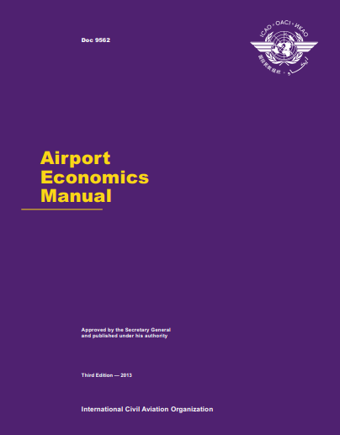
Figure 1.1 - Airport Economics Manual (Doc 9652 ICAO)
This guidance material takes into account a wide range of different conditions faced by airport operators. It is based on international policies and principles regarding the reimbursement of airport costs, which were developed by countries with the assistance of ICAO, and describes procedures and practices that are consistent with these policies and principles.
Doc 9652 describes basics of ICAO principles on airport charges. So that nation, subject to possible abuse the dominant position of airports, is responsible for the economic oversight of their operation. Economic supervision is defined as a function by which the state controls the operation of commercial and operational structures of the airport. Performing its function economic supervision, the state should ensure that airports consult in users and the creation of appropriate performance management systems.
Various organizational structures can be divided into two main types. The first type includes state or public ownership and control. Although it is still the predominant organizational form, many states have established autonomous bodies, separating the provision of airport services from executive functions of the state and allowing them to function on a commercial basis. Second type implies the full or partial presence of the private sector, and this form is gaining more and more spread. Subject to various circumstances, this manual does not aim to recommend a particular organizational form, but rather offer states an instructional material describing the relevant features of each form.
Contracting countries for using airports and aeronautical means by aircraft of any other contracting state, should not exceed:
- in respect of aircraft not engaged in regular international air services - charges that would be levied on their national aircraft of the same class engaged in similar communications;
- in respect of aircraft engaged in scheduled international flights communications - charges that would be levied on their national air vessels engaged in similar international air services. Information on all such fees is published and communicated by the International civil aviation organizations, while at the request of the interested Contracting State levies for the use of airports and by other means, subject to consideration by the State, which represents them report and makes recommendations for consideration by the state concerned or by states.
Experience accumulated throughout the world indicates that where airports and air navigation services are operated by autonomous entities, their general financial situation and management effectiveness is generally improving. In this regard it is recommended that nations consider establishing autonomous structures to operating their airports or air navigation services when it is economically viable and responsible interests of suppliers and users.
1.1.2. Doc 9137 ICAO - Airport Services Manual
This document includes following parts [2]:
Part 1 - Rescue & Fire Fighting (RFF).
This part introduces the main principles of fire service and different rescue procedures.
Regarding the document, a Rescue and Fire Fighting service exists in order to predict people loss during any accidents and incidents on the airport area or on its vicinity. The main RFF’s aim is to provide the victims with safe conditions, conduct exit procedures for occupants and to give a first air to people who need it.
Part 2 – Pavement surface conditions
The effective use of the aerodrome may be highly dependent from natural features and artificial structures located within the aerodrome and beyond its borders. They can limit the available take-off and landing distances and the range of weather conditions under which take-off and landing can take place. On these reasons, certain areas of local airspace should be considered as an integral part of the aerodrome environment. Degree of clearing of obstacles in these areas is an equally important factor for safe and efficient use the aerodrome, as well as the more optimal physical characteristics of the runways and associated flight lanes.
Part 3 - Wildlife Control and Reduction
Analysis of bird/wildlife collision data, observations and monitoring their behavior, allows to identify trends, the study of which will enable the authorities the airport to identify troubling problems (Fig. 1.2). Solve these problems with the help of good organized wildlife control program. Aircraft collision statistics with birds/wildlife can also be analyzed in order to determine the seasons or the time of day at which bird/wildlife behavior is most needed to be controlled.
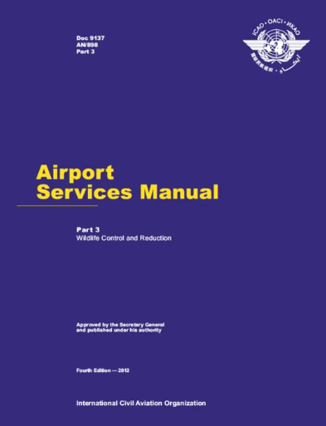
Figure 1.2 - Airport Services Manual Part 3 (Doc 9137 ICAO)
Part 4 – is no longer valid.
Part 5 – Removal of Disabled Aircraft
The purpose of this guide is to assist different countries, aerodromes and operators aircraft assistance in solving problems associated with damaged and lost ability to move aircraft at the airport.
Past consequences of minor incidents liquidated relatively easily. Aircraft removal process complicated by the increase in the size and weight of aircraft.
Part 6 - Control of Obstacles
The effective use of the aerodrome may be highly dependent from natural features and artificial structures located within the aerodrome and beyond its borders. They can limit the available take-off and landing distances and the range of weather conditions under which take-off and landing can take place.
On these reasons, certain areas of local airspace should be considered as an integral part of the aerodrome environment. Degree of clearing of obstacles in these areas is an equally important factor for safe and efficient use the aerodrome, as well as the more optimal physical characteristics of the runways and associated flight lanes.
Part 7 – Airport emergency planning
Airport emergency planning is a process of preparing the airport in case of emergency situation in the airport or on its surroundings. Every emergency plan at the airport is program of action serving the airport and its surrounding areas.
The purpose of emergency planning for an airport is to minimize consequences of emergencies, foremost with the goal of saving lives and providing of safe flights of aircraft.
Part 8 – Airports Operational Services
There is a big amount of procedures and measures are described. For example: rescue and fire fighting, movement area inspection, surfaces of obstacle limitations, inspections of visual aids, electricity systems state and movement areas.
Also there is information about different levels of movement are access and their difference in the Part 8. And, of course, one the main safety measure is emergency plan and stuff preparation for each dangerous situation.
Part 9 – Airport maintenance practices
Proper maintenance of airport facilities is important for both the safety of aircraft and the extension of the term operation of these funds. Nevertheless, when considering budgetary allocations for airports, maintenance is often ignored or funds allocated to it are reduced. This guide is expected to help determine the appropriate place for maintenance in the overall airport program.
This document is significant for airport management and handling, it determines the terms of interaction of every service at airport.
1.1.3 Doc 9626 ICAO - Manual on the Regulation of International Air Transport
The main purpose of the guide lies in meeting the ever-growing need for a comprehensive and objective source of information on various aspects of this dynamic activity [3].
This manual is designed so that it to be convenient to use and serve three specific tasks. Firstly, it can be used as a dictionary of international air transport terms: each term given in the subject index has a definition or explanation on the indicated page (Fig 1.3).
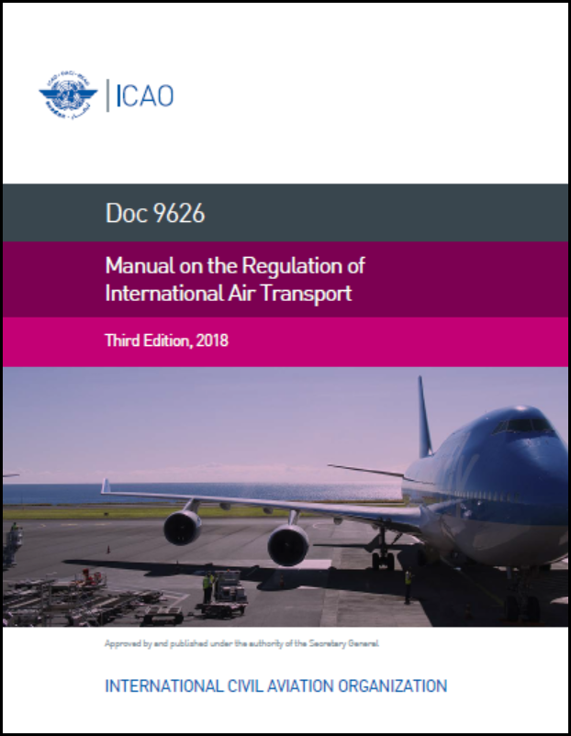
Figure 1.3 - Manual on the Regulation of International Air Transport (Doc 9626 ICAO)
Secondly, the guide can be used as an encyclopedia. Each broad regulatory issue is included in a separate chapter or section of a chapter of the Guide, written to summarize key facts on one or more pages. A table of contents helps the reader locate the material on broader issues (for example, the bilateral regulatory process, transport rights, and so on each of which may contain several interrelated explanations and definitions).
Of particular importance in the national regulation of international air transport are the principles of courtesy and reciprocity, especially in cases where any business is not covered by special provisions in the agreement on air transport.
Courtesy is the proper respect shown by the authorities of one state to the official acts of another state. In regulation practice, politeness sometimes implies the unilateral granting of the right or privilege of a foreign airline without necessarily relying on the same attitude from the state of such an airline in similar circumstances. For example, a state based on the principle politeness, can allow preferential rates, which the government of a foreign state ordered its national airline to provide it to officials.
In contrast, reciprocity is granting a right or privilege by a state to a foreign organization, for example, an air carrier, in those cases when it has no international obligations in connection with this, provided that the same regime will be granted to its similar organization (organizations) by the state of that foreign organization. For example, a state may allow an intermittent flight or flights of a foreign airline if the state of the airline in the past permitted or promises to allow future irregular flights or flights of an airline (airlines) of the first state.
Bilateral regulation is regulation carried out jointly by two parties, in the most of cases usually by two states, although one of the parties or both parties may also be a group of states, a supranational structure (e.g. a community or other association of states acting as a single entity within authority granted to it by the participating States), regional state authority or even two airlines (for example, when determining traffic volumes or prices). The objective of bilateral regulation in the field of international air transport is usually the conclusion, implementation or extension of certain intergovernmental agreements or arrangements for air traffic between the territories of these two parties.
Bilateral Air Transport Agreement or an air services agreement, a core document most commonly used by states for joint regulation of their relations in the field of international air transport, as a rule, consists of the text part (preamble, articles, signatures), application or applications, possible additions and any agreed amendments. Such an agreement is often referred to as those who constantly regulate international air transport, simply as "bilateral." Most bilateral air agreements transport covers only regular international air transport, but some of them are also regulated by irregular international air transport. The Scheduled Air Services Agreement, or the charter agreement governs non-scheduled or charter air services separately from regular international air services. A Memorandum of Understanding (MOU) is a less formal type of agreement that, although less formal, may be the same, binding, like a formal agreement, and may cover one of two or both types of international air transportation.
1.1.4 Freedoms of the air
Freedoms of the air are a set of civil aviation rules that entitle airlines of one country to enter the airspace of another country and land on its territory, formulated as a result of disagreements about the degree of aviation liberalization laid down in the 1944 Convention on International Civil Aviation, also known as Chicago Convention [4]. Most countries were preoccupied with the dominant position that major. The visual description of Freedoms is shown at Fig. 1.4.
Table 1.1 – Freedoms of the air
№ | Description | Example
1 | 2 | 3
The First Freedom | The right to cross the airspace of a foreign nation not landing in it. | Flight Kyiv – Berlin, performed by Ukrainian carrier, flying over Poland.
The Second Freedom | The right to have a refuel service without disembarking and boarding again of passengers and cargo. | Flight Kyiv – Sanya (China), performed by Ukrainian carrier, refueling in Almaty.

Continuation of Table 1.1
№ | Description | Example
1 | 2 | 3
The Third Freedom | The right to perform a flight from country owning the aircraft (airline) to another country. | Flight Munich – Kyiv by German carrier.
The Fourth Freedom | The right to perform a flight from another country to a country owning the aircraft (airline). | Flight Kyiv – Munich by German carrier.
The Fifth Freedom | The right to perform a flight between two foreign countries, when its origin or destination is owner’s country. | Flight Kyiv – Colombo (Sri-Lanka), performed by Ukrainian carrier, refueling in Antalia. Passenger have a right to fly the route Colombo-Antalia, without intension to fly to Ukraine.
The Sixth Freedom | The right to fly from a foreign country to another foreign country with a stop in its own country without technical reasons. | The flight Kyiv – Dubai – Sydney, by Emirates carrier without any technical necessity.
The Seventh Freedom | The right to fly between two foreign countries without landing in its own country. | The flight Kyiv – Warsaw performed by Irish carrier.
The Eighth Freedom | The right to fly from one airport to another within one foreign country with the continuation of the flight to its own country. | The flight Kyiv – Warsaw – Dublin performed by Irish carrier.

Continuation of Table 1.1
№ | Description | Example
1 | 2 | 3
The Ninth Freedom | The right to fly within one foreign country without continuing to fly to its own country. | The flight Glasgow – London performed by Irish carrier.

Regarding information under we can realize how useful these freedoms can actually be:
- The Fifth Freedom is often used by airlines to increase passenger flow on some routes. And countries give this right to others for the sake of tourism development, in order to increase the flow of visitors, or to increase the number of flights on those routes where there are not enough airlines.
- There is an agreement on transit through international airlines, it is abbreviated as the Agreement on Two Freedoms, according to which the member countries provide each other these Freedoms for a fee not exceeding what they charge from the airlines of their country.
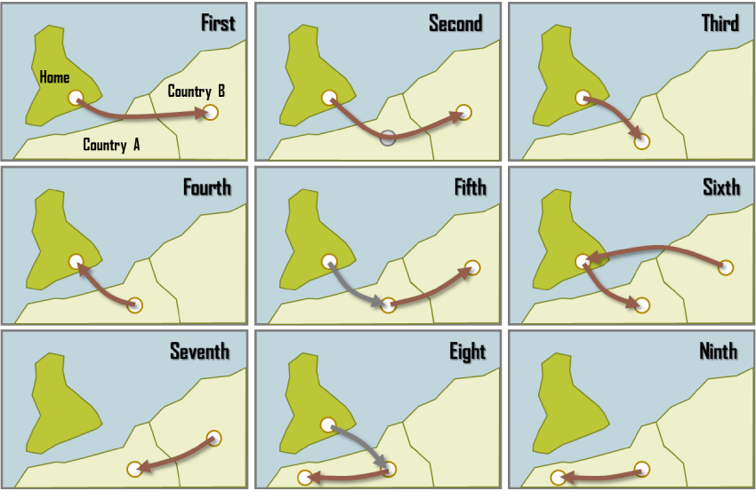
Figure 1.4 – Visual description of Freedoms of the air
This agreement includes about 130 countries, including the United States, India and Australia. However, several large countries decided not to participate in it. Especially Canada, over whose territory many polar routes pass, it prefers to negotiate separately with each country and collect more serious money for transit.
1.1.5 Doc 9082 ICAO - Policies on Charges for Airports and Air Navigation Services
As a general principle, it is advisable that, in cases where the airport is intended for international use, users ultimately pay fully and fairly their share of the cost of operating the airport [5]. Therefore, it is important that airports keep records to provide relevant information in order to meet the needs of both airports and users and that, whenever possible, the types of equipment and services related to airport charges. In determining and distributing the total costs offset by international air transportation service charges may serve as a reference for equipment and services that should be considered. Airports should keep records in order to provide a satisfactory basis for determining and allocating reimbursable expenses, regularly publish their financial statements and provide relevant financial information in consultation with users. How this document looks like is introduced at Fig. 1.5.
In determining the cost basis of airport charges, the following principles should be followed:
- Distributable costs are the full costs of supporting the airport and its necessary support services, including the corresponding amounts for paying the cost of capital and depreciation for fixed assets, as well as expenses related to technical maintenance, operation, management and administration. Given the accepted form of economic supervision, these costs may be covered by non-aviation income.
- In principle, aircraft operators and other airport users should not be charged for equipment and services that they do not use, with the exception of those provided for and put into operation in accordance with the regional air navigation plan. Only the costs of equipment and public services in international air transport should be included and excluded are the costs of equipment or premises that are rented or used on special conditions and for which a separate fee will be charged.
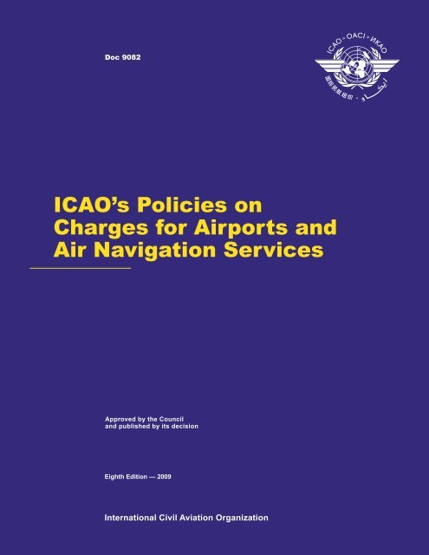
Figure 1.5 - ICAO Policies on Charges for Airports and Air Navigation Services (Doc 9082 ICAO)
- Although airports should maintain sufficiently detailed cost data to facilitate consultation, transparency and economic oversight, it may be useful to develop a more aggregated cost basis for setting fees. However, aggregation should be carried out in a logical and transparent manner, accompanied, as appropriate, with guarantees regarding consultation and agreement with users, in order to avoid discrimination among users.
- Consideration should be given to the distribution of costs in relation to production facilities or equipment used by state authorities.
- Ratio of costs shared between different categories of users, including government aircraft should be determined fairly in a manner that so that no category of users incurs expenses incorrectly attributed to its account, based on sound accounting principles.
- Costs related to the provision of supervisory services should be separately identified approach and aerodrome control services.
- Airports can receive sufficient revenues in excess of all direct and indirect operating costs (including general administrative, etc.), and thus have reasonable return on assets at a level that allows for effective financing in capital markets to invest in new or developing airport infrastructure.
- The solvency of users should not be taken into account until all expenses are fully calculated and allocated on an objective basis. At this stage, it is necessary to take into account the payment capacities of the respective states and population, taking into account the fact that any state or authority charging fees may not fully recover the costs incurred based on recognition of the benefits received locally, regionally or nationally.
- The costs directly related to the oversight functions (safety oversight, aviation security and economic oversight) in relation to airport services may, at the discretion of the state, be included in the airport's cost structure.
Airport Tax Collection Systems
Charging systems at international airports should be selected in accordance with the following principles:
- Any toll system should be as simple as possible and suitable for general use at international airports.
- Fees should not be imposed in such a way as to impede the use of facilities and services necessary for safety, such as lighting and navigation aids.
- Fees should not be discriminatory both against foreign users and users who have the citizenship of the state in which airport, and performing similar international transportation, as well as in relations between two or more foreign users.
- In order to prevent unjustified harm to users, an increase in fees should be carried out gradually; however, it is recognized that, under certain circumstances may necessitate non-compliance with this approach.
- The size of airport charges levied on international general aviation.
- Business aviation should be determined on a reasonable basis, considering the cost of necessary and means and goals used to promote the sustainable development of international civil aviation in general.
Landing fees
When establishing landing fees, the following principles should be considered:
- Landing fees should be based on the maximum weight of the aircraft certified take-off weight indicated on the flight certificate (or other prescribed document), taking into account local restrictions that may affect maximum take-off weight of the aircraft. In certain circumstances, such as congested airports and “peak” periods, fixed fee allowed per aircraft or fixed fee combinations with a weight related item.
- Where approach control and aerodrome control fees the service is charged as part of the landing fee or separately, they must comply policies regarding air navigation services charges.
- The length of the flight phase should not be taken into account when determining the size of landing charges.
Parking and hangar fees
When setting charges for parking and use of hangars, the following principles should be followed:
- When determining the fees associated with the use of parking lots, hangars and long-term storage of aircraft, the maximum allowable take-off weight and / or dimensions of the aircraft (occupied area) and the duration of parking should be used as a basis, as far as possible.
- Any period of free aircraft parking immediately after landing should be determined on the spot, taking into account the schedule, availability of parking spaces and other relevant factors.
Passenger Service Fees
In order to avoid queuing and delays at airports, the issue of the efficiency of charging passenger service fees should be considered. In cases where levying a passenger service charge directly from each passenger at the airport creates a simplification problem, these fees should be levied with the involvement of aircraft operators, if practicable. The need for consultation between airport authorities and users at the local level should be emphasized in order to address charging problems.
States are responsible for taking appropriate security measures in airports in accordance with the provisions of ICAO Appendix 14 "Aerodromes" to the Convention on International civil aviation. They can entrust the task of performing certain functions related organizations such as airports, aircraft operators and local police. States themselves determine under what circumstances and to what extent the costs of the provision of facilities and security services should be covered by the state, airports or other responsible institutions. Regarding reimbursement of security costs for user account, the Council recommends the application of the following general principles:
- Before airports, aircraft operators or other entities incur expenses for security should be consulted.
- Relevant entities may reimburse costs associated with security measure, security at airports, at the expense of users in a fair and objective manner, considering consultations.
- Any security fees, or security costs, that are payable to service providers, aircraft operators and/or end users should be directly linked to the costs of providing specific security services, as well as calculated taking into account the reimbursement of an amount not exceeding specifically incurred expenses.
- The civil aviation expense should not be charged the implementation by States of more general security functions, such as police policing, intelligence gathering and provision of national security.
- When charging a specific level of security for various user categories should not be discriminated against. Certain categories users can also be charged for additional costs incurred on providing additional levels of security provided to them regularly upon request.
- When reimbursing security costs at airports using fees, Apple discretionary method, but such charges should be established either by the number of passengers, or would aircraft weight, or taking into account both factors. Safety costs allocated among airport tenants, you can reimburse in the form of rent or other fees.
- Security fees may be charged either as additional to others already applicable fees, or in the form of separate fees, but they must be subject to separate definition of costs and related justification.
Noise Charges
Despite the reduction in aircraft noise at source, many airports still need to take measures to reduce or prevent noise. The costs associated with such measures may, in State discretion, be assigned to airports and offset by users. States flexibility is provided when choosing a method of covering costs and charging fees, taking into account local conditions. In case of charging noise related charges. Anyone should be consulted and cost-compensated users and be guided by the following principles:
- Noise charges should be charged only at airports where problems exist noise, and they should be installed in sizes that do not exceed the costs incurred noise reduction or warning.
- Any noise-related charges must be associated with landing charges, possibly through additional fees or discounts.
- Noise charges should not discriminate against users and should not be installed in sizes that are excessively high for operation of some aircraft.
Increase in income from rental of premises and “open areas”
Income derived from sources such as concessions, rental of premises and "open areas", important for airports. It is recommended to fully utilize the possibilities of increasing non-aviation income, with the exception of concessions that are directly related to the activities of such services air transport, such as fuel supply, on-board catering and ground handling, while ensuring the interests and needs of passengers, the public and the effectiveness of the terminal.
Facilities and services during approach, landing and take-off:
- Landing area with obstacle-free approaches and taxiways with necessary drainage, fencing, etc. Also, approach lights, landing lights, taxiway lights and lights for take-off, as well as communications and other special means for approach, landing and take-off (sometimes provided by non-airport operator).
- Approach and aerodrome control services: management of air traffic during approach, landing, taxiing and take-off with the necessary support services, communications, navigation and surveillance. (Approach and aerodrome control service is sometimes provided in whole or in part by another party other than airport operator).
- Meteorological Services (MET) (often provided by a non-party airport operator).
- Permanent fire service and ambulance service.
- Airport buildings, aircraft parking lots, hangars and other facilities and services provided to aircraft operators, such as:
- Passenger and public waiting rooms and vestibules with the necessary heating, lighting, utility service, access roads, etc.
- Premises for aircraft operators, registration desks , crews, passenger services and cargo handling.
- Assistance in passenger service and cargo handling and necessary equipment.
- Special aircraft services (air conditioning, cleaning, etc.).
- Towing and other types of aircraft services.
- Places of parking and long-term storage of aircraft.
- Hangars, workshops, warehouses, garages and other technical rooms. Land leased to aircraft operators for various purposes.
- Supply of aviation fuel (usually through concessions) and other technical materials, as well as aircraft maintenance and repair.
- Communication facilities (messages of flight operating enterprises - class B).
- Common services such as lighting, heating, electricity and heating fuel.
Security measures, equipment, facilities and personnel to perform the functions listed below:
- Control for security purposes, including screening passengers and their cabin baggage. Security controls, including inspection of checked baggage.
- Security controls for cargo, mail and other goods.
- Security controls for airport personnel and airlines.
- Surveillance of aircraft and restricted areas.
- Verification of personal data on persons entitled to enter protected restricted areas.
- Identification systems for airport security.
- Security personnel training.
- Premises for institutions and organizations other than aircraft operators
- Premises for non-aeronautical facilities such as shops, hotels, restaurants, ground transportation services, banks/exchange offices, post offices and telecommunication facilities.
- Means paid directly by the population (parking lots, viewing platforms, etc.).
- Premises for the necessary public services: customs, immigration, medical center, agricultural quarantine, etc.
- Land leased to other parties, in addition to aircraft operators
- Noise control systems, sound attenuation equipment and noise barriers.
- Land or property acquired around airports.
- Soundproofing buildings near airports and other noise reduction measures, including measures arising from legal or state requirements.
- Reduction and prevention of emissions affecting local air quality:
- Monitoring of the air quality at and around the airport.
- Airport emission inventory and variance modeling.
- Installation of stationary ground-based power supplies and air conditioning for air vessels in parking lots in order to reduce emissions.
- Installation of gas stations using low emission fuel (e.g. liquefied natural gas or biofuel) in equipment for ground handling of aircraft and vehicles in a controlled area, in order to reduce emissions.
- Improving aircraft ground handling systems, in particular on taxiways, in order to reduce emissions.
1.1.6 Annex 14 ICAO – Aerodromes
This Annex contains Standards and Recommended Practices (Technical Requirements) that prescribe the physical characteristics and surfaces of the obstacle restrictions that need to be provided at aerodromes, as well as certain equipment, facilities and maintenance that are typically provided at the aerodrome [6]. It also contains technical requirements for obstacles located outside such obstacle restriction surfaces. Annex is depicted on Fig. 1.6.
These specifications are not intended to limit or regulate aircraft operations. The purpose of these requirements is to create a regulatory regime that provides the ability to effectively comply with the technical requirements of this Annex.
This document sets out the minimum technical requirements for aerodromes designed for aircraft having the same characteristics as those currently in operation, or for similar aircraft scheduled for commissioning. Therefore, no additional measures that could be considered appropriate for servicing aircraft with enhanced performance are not taken into account. Such issues, as necessary, are evaluated and taken into account by the competent authorities for each individual aerodrome.
It is generally recognized that the principles of ownership of aerodromes, the systems of their operation and supervision of activities in different countries are different. The most effective and transparent means of ensuring compliance with the established requirements is the existence of a separate safety control body and a well-functioning safety control mechanism, as well as relevant legislation, which allows the regulatory function to be implemented in the field of safety at aerodromes.
The fact that the certificate is issued to the aerodrome is an indication to the operators of aircraft and other organizations using the aerodrome that at the time of certification the aerodrome meets the requirements for the aerodrome complex and its operation and, in the opinion of the certification authority, it provides opportunities to comply with these requirements for a period of time certificate validity.
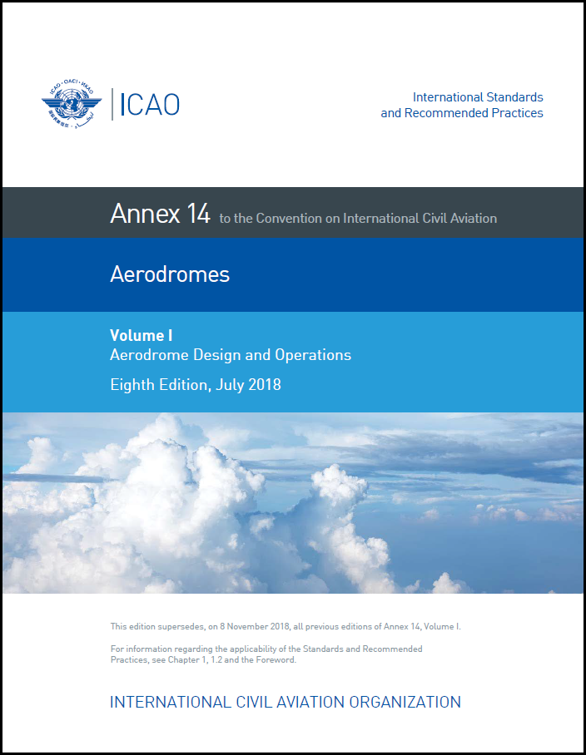
Figure 1.6 – Aerodromes (Annex 14 ICAO)
1.2 Legislation background for airport functioning based on IATA documents
1.2.1. IATA Resolution AHM-810 – Standard Ground Handling Agreement
This document describes main principles of interaction between airport and airline. The appearance of this document at Fig. 1.7.
Services are provided within the capabilities of the Airport and in accordance with the applicable rules, regulations and procedures of IATA and/or ICAO. The airport provides all technical support and flight services in accordance with the instructions of carrier. In the absence of instructions from the Carrier, the Airport performs work in accordance with its own regulatory practices and procedures [7].
Other services also related to security, such as loading control, loading onto aircraft and handling of dangerous goods, must be carried out in accordance with the applicable rules, regulations and procedures of IATA and/or ICAO.
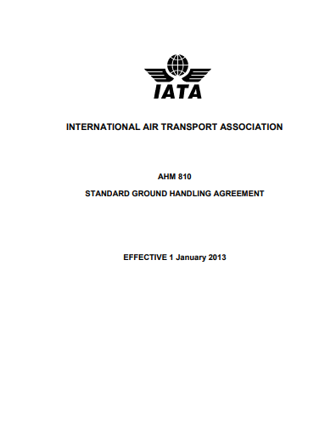
Figure 1.7 – Standard Ground Handling Agreement (AHM 810 Resolution IATA)
When providing services in general, special attention should be paid to ensuring safety, reliability, compliance with domestic and international rules, regulations and procedures applicable to IATA and/or ICAO, as well as the aforementioned Carrier's requests/in order to prevent delays and damage to air Carrier ships and cargo and create a favorable impression of the operation of air transport. Responsibilities of airport can vary depending on the situation. Main and common responsibilities will be provided below.
To provide the presence of special equipment, facilities and specially trained personnel available to assist with:
- unaccompanied children;
- persons with disabilities;
- dignitaries;
- transit passengers without a visa;
- deportees;
- to other specially designated persons.
Depending on the circumstances, airport is required to arrange storage of luggage in a customs warehouse, if necessary (any fees are paid by the passenger).
Regarding the communication with passenger, airport has to provide such kinds of interaction:
- Notify the airline of complaints and claims from the Carrier's customers, and, according to a special arrangement, settle such claims by mutual agreement.
- Settle issues of lost, found and damaged property by mutual agreement.
- Inform the Carrier of any violations in the service of passengers and baggage.
- Provide special facilities for passengers to relax (lounges, waiting zones).
Considering passenger ground handling airport must provide:
- Personnel and/or means for carrying baggage.
- Check the validity of tickets for the flight s on which they are presented. Verification does not include payment.
- By mutual agreement, check the documents necessary for the flight (passports, visas, vaccination certificates and other papers)
- Weigh and / or measure (as the case may be) and tag the checked and unchecked baggage.)
- Carry checked baggage from the baggage check-in area to the baggage sorting area.
- Enter baggage information in passenger tickets, tear off appropriate flight coupons and issue boarding passes for the flight;
- Collect airport taxes, if any, are collected from departing passengers and report on them to the appropriate airport authorities.
- Carry out the allocation or selection of seats determined by the Carrier
- Check the number of passengers after boarding.
- Solve compensation issues for denied boarding as agreed with the Carrier.
- Provide funds for the reception and handling of unaccompanied baggage.
Airport is required to provide such services due to baggage procedures:
- Deliver baggage in accordance with the rules of the airport.
- Handle baggage in baggage sorting area.
- Prepare for shipping: non-containerized baggage, means of baggage packing.
- Determine the weight of baggage bagging equipment.
- Unloading non-containerized baggage from vehicles.
- Disassemble and / or unload baggage packing equipment.
- Check incoming baggage for transfer docking points.
- Sort transfer baggage.
- Store transfer baggage for a mutually agreed period of time until departure.
- Handle crew baggage by mutual agreement.
Airport by the mutual agreement with carrier must:
- Inform passengers and others about the time of arrival / departure.
- Carry out services for departing passengers and luggage.
- Direct departing passengers to transport transporting to the airport.
- Take passengers arriving from the airport with transport.
- Deliver baggage to passengers in accordance with the rules of the airport.
As a ground handling provider airport have to provide such facilities:
- Escort machine for arriving and departing aircraft.
- Install and/or remove parking pads.
- Install and clean engine plugs, appropriate passenger ramps, appropriate loading conveyors, ladders for the crew.
- Provide transportation for passengers and crew between the aircraft and the terminals.
- Provide appropriate equipment for loading and / or unloading
- Operate appropriate equipment for transporting baggage, cargo and mail between agreed points at the airport.
- Deliver cargo and mail.
- Load, stack and secure baggage; cargo and mail on the aircraft in accordance with the instructions and rules of the Carrier.
- Use on-board loading equipment in accordance with the instructions of the Carrier.
- Redistribute loading on an aircraft in accordance with the instructions of the Carrier.
- Ensure the safety of all types of loading, paying particular attention to valuable goods and goods of increased vulnerability during loading / unloading and during transportation between the aircraft and airport buildings.
Due to aircraft service airport is required to supply
- Appropriate equipment for towing nose forward and / or tail forward.
- Tow the aircraft nose forward and / or tail forward in accordance with the instructions of the Carrier.
- Tow the aircraft between other agreed locations in accordance with the instructions of the Carrier.
- Move the aircraft with its own thrust in accordance with the instructions of the Carrier.
Besides, airport is obviously have to ensure cleaning procedures of cabin, ashtrays, seats (including the pockets), tables, toilets, kitchens, baggage compartments.
1.2.2 IATA Passenger Services Conference Resolutions Manual
The main aim of this manual is to include and distribute in one guide all resolutions which were published for conferences regarding passenger services. Besides, an important purpose is to publish all recommended practices for further implementation and usage in the airports, airlines, agencies etc.
There are following issues described in the Manual:
- Rules and practices to establish growth and development of passenger service organization and management.
- Procedures for issuing the ticket, its revalidation, refund, re-issue processes, issuing the EMDs.
- Collection of penalty fees.
- Involuntary changes – procedures when due to some reasons (logistical lack, technical problem, weather conditions) route, dates, flights must be changed to ones that are mostly necessary and comfortable for passenger.
- Different procedures and amendments for serving PRMs.
- Fourteen levels of passenger service description.
This guide can be very useful for effective search, as all resolutions are ordered by the number and issue they are describing [8]. Groups are following:
700 – 719 – Passenger processing
720 – 739 – Ticketing
740 – 759 – Baggage
760 – 779 – Reservations
780 – 799 – Miscellaneous
So, let me start with the very first service provided to passenger – ticketing procedure. IATA in the sphere of flight booking is the organizations which establish and regulates the rules and rights for ticketing.
First of all, electronic ticket – is an electronic document certifying an air carriage agreement between a passenger and an airline. Example of electronic ticket you can be found in Appendix A.
Generally, booking consists of following elements:
- Full name and type of passenger:
The passenger's name and surname are written in Latin. The type of passenger is indicated in brackets next to the name and surname. Here are some of the most common: ADT (Adult) - adult, CHD (Child) - baby, INF (Infant without a seat) - baby without a seat, INS (Infant with a seat) - baby in a separate place, UNN (Unaccompanied Child) - unaccompanied child.
- Booking code and ticket information:
Reservation code (PNR, Booking reference, Confirmation number) - a reservation code, a six- or five-digit sequence of letters and numbers. The code can check the status of the ticket.
Issue date - date of purchase of the ticket;
Ticket number;
Issuing airline;
Issuing agent - The agent who issued the ticket, or its code, at the IATA (International Air Transport Association).
- Route information:
Itinerary details - route information;
Travel date - date of flight;
Airline;
Flight (in our itinerary-receipt there is no word, it is implied) - flight number. The first two letters are the airline code assigned to IATA, such as Ukraine International airline - PS, Lufthansa - LH, Turkish Airlines - TK, LOT Polish Airlines - LO.
Departure (From) - departure from the city and departure airport. The name of the airport can be written in full or with the IATA code, for example, Boryspil - KBP, Paris Charles De Gaulle - CDG, Frankfurt International - FRA;
Time - departure time. Always write local time;
Terminal - departure terminal;
Arrival (To) - Arrival Airport;
Time - time of arrival. Always write the local time of arrival;
Terminal - arrival terminal.
Other notes - other information:
Class is a service class. Can be specified completely or in one letter: Economy (Y, B, E, H, K, L, M, N, Q, T, V, X) - different types of economy class, Business (C, D, J, I , Z) - business, First class (F, A, P, R) - first and Premium economy (W) - premium economy class (middle between economy and business classes). For some airlines, the alphabetical codes of the service classes may differ;
Seat number - Check-in required - will be assigned after registration;
Baggage allowance is the standard of free luggage. The allowed luggage weight in kilograms can be written: 20 kg (20 kg) or the number of luggage places 1PC (1 place). In the second case, look for the maximum weight of one seat on the website of the airline or check with the customer support;
Booking status - booking status: Confirmed (Ok) - paid and confirmed, Needs payment - not paid;
Fare basis - the tariff code at which the ticket was purchased. The service class is encrypted. In addition to basic information (first, business, premium, economy), it may contain additional, for example: low season flight, baby fare, round trip, without the ability to hand over or exchange a ticket. Many airlines have their own system of symbols, which form the fare, others use the commonly accepted codes. If you want, try deciphering your ticket;
Not valid before (NVB), Not valid after (NVA) - ticket validity. If the fare allows you to exchange your ticket, you will be able to fly the next day within the specified dates. If you cannot exchange your ticket, both points will have a flight date. To provide opportunities to agents to issue tickets from name of Airlines, each airline issues a permit for ticket statement to each agent, with which it has contractual relationship. Agent can write out standard transportation documents for any Airline - BSP member, issuing permission to ticketing. In case if booking contains transportation segments, performed by several carriers, choice issuing airline carried out by the Agent in according to the procedure described in the Selection Rules.
- Payment/Fare details - Payment information/Fare calculation
Form of Payment - Credit Card - bank card number, Cash - cash, Invoice (INV) - non-cash payment;
Endorsement / Restrictions - The rules and restrictions applicable to the tariff, as well as any special marks. For example, Non-Ref (Non refundable) is a non-refundable ticket. Changes Permitted Fees App (apply) - You can change the departure date and / or route with a fine. Non-Reroutable - You cannot change your trip itinerary. Non-End (Non-Endorsable) - A ticket cannot be re-issued for another airline's flight. Special notes are, for example, passport data or information that the ticket has been reissued;
Fare Calculation Line - calculates the fare for each flight segment. It consists of three-letter city codes, two-letter airline codes and a tariff, calculated on neutral NUC units used in aviation. They are translated at the rate of ROE - Rate of Exchange published by IATA;
Fare - fare in the currency of the country of departure or in US dollars;
Taxes / Fees / Carrier-imposed charges - taxes and fees included in the final cost of the ticket in addition to the fare. Fuel surcharge - can be denoted by the code YQ. Airport charge / fee is an airport fee. Service fee / carrier surcharge (YR) - A service charge from an airline or agent, for example, for a ticket at a ticket office, a paper ticket, or a ticket reissue if a passenger changes his / her surname. Depending on the country and route, other taxes and fees, including state taxes, may apply;
Ticket total - the total cost of a ticket in the currency of the country of origin or in US dollars.
BSPlink is a method of communication for all BSP members via the Internet. It will be in BSPlink Agent to receive all of your BSP Reports as well as Report Correction Messages (ADM / ACM), n addition, Refund Applications are entered and processed on BSPlink Agents and Airlines.
In BSPlink, you can get up-to-date reports, BSP archive data (documents and ADMs up to 13 months), create groups from IATA locations, receive emails about new files and much more.
Airlines use Ticketing Authority in BSPlink to manage the Right for e-ticketing for Agents, so BSP can always check the list of airlines that gave him permission to issue tickets. Access to Ticketing information authority has Airlines, Agents and GDSs, meaning BSPlink provides full transparency between all sides of the process.
IATA downloads files with important online information to the site using function file download. Visit the BSPlink website regularly to check for new ones files, reports, ADM / ACMS, BSP Newsletters for new or changed procedures.
IATA provides Agents with a standard set of BSP Reports for each reporting period, at electronically via BSPlink. BSP reports are the final billing statement and accountof the funds transfer agent and, as such, will be different from the reports prepared the Agent himself and reports from GDS. The reason for these differences is that the BSP Reports on calculations will include data from all market actors, not just the Agent. Some input data agent may be corrected during processing in the BSP; some data provided by others entities may affect the amount of the Agent's settlements (eg ADM and ACM from BSP Airlines).
Ticket must be issued only for one airline (code-share flights are allowed) or for different ones but common fares must be agreed and provided to agents or directly to passenger. Also there special rules, that cannot be broken in case of neglection – ADM policies will be applied. ADM is kind of fee that is taken from agent or agency when there are disregarding in the booking. For example, during the reservation it is obvious to put into the system phone or e-mail of passenger, if agent have not done it – ADM will be applied.
The ticket is valid only in the sequence it is issued: for the origin to destination point. Unless flight and baggage coupons must be honored in the right order, it will lose its validity. For example, the passenger is flying the route Kharkiv – Kyiv – New York, he decided to get to Kyiv by car, not by plane. As he is absent on flight Kharkiv – Kyiv the air company cancels his coupon Kyiv – New York, as he is not supposed to fly the further route. That is why in Kyiv passenger will not be able to board the aircraft, as his coupon will not be valid anymore.
The Agent shall be entitled to refund only those tickets (STD) that have been issued and reported directly by that Agent. In all other cases, the Agent must obtain prior approval from the Airline to which this document belongs.
The agent must make the Return of Tickets, first of all, in his GDS (Direct Return - Automatic Return via GDS) system and whenever possible. The form of payment indicated on the ticket must always remain the same in the Returned Ticket Return.
In all cases where the Return of the Agent's document requires the prior approval of the Airline, or for reasons of established rules, or if the Agent is unable to calculate the amount of the return on its own, the Airline Refund Application / Authority function in BSPlink must be used.
Procedures for automatic GDS / Ticketing System Returns Report:
• The agent must check whether the ticket can be returned in accordance with the applicable fare rules and the Airlines' rules for the ticket that was issued.
• The agent must carry out the Return operation on the same GDS / Ticketing System where the original document was issued (contact GDS if you have any questions regarding the Return).
Carrier is fully responsible for any passenger loss or injury, the limits of compensation are following:
- There are no limits for death or body injuries compensation.
- Regarding baggage loss, damage or delay the limit is 1200-1500 Euros in the most of cases.
- For damage that was caused by delay the limit is 5000-6000 Euros.
Anyway, the amount of compensation is set by carrier. If passenger journey involves different carriers, the passenger should contact each one to find out about the liability of his loss.
Regardless, the amount of compensation described above, passenger can use special procedure of declaration the baggage while checking in and pay some supplementary fees. But in case of baggage loss, damage or delay the compensation by airline cannot be limited by any of limitations of liability.

CONCLUSION TO CHAPTER 1
As we investigated in Chapter 1, the legislation basis is quite developed and adapted to airports’ effective functioning. Many documents are being designed in order to cover all spheres regarding airport handling and economics.
ICAO and IATA documents are the most significant standards and instructions that are used at vast majority of the world airports. The main functions of these publications is to perform control of aerodromes and aircraft operation by sharing of experience of global practices. Mentioned background is used in Ukrainian airports and have an influence on local aviation legislation, as Ukraine is ICAO-member and IATA-member. Usage of the world practices is quite important for every nation and every airport, as it joins all the aerodromes into one big group, which helps to proper each one’s functioning. Global legislation is essential feature of the world aviation, because it has an effect on every function performed by the airport, such as:
- check-in procedures;
- baggage procedures;
- security control;
- border control;
- customs control;
- aircraft maintenance and handling;
- boarding procedures etc.
All above documents were designed with a purpose to make every airport to interact with each other. As well as to avoid failures in serving the passenger begging from buying a ticket and going out form airport at the point of destination.
CHAPTER 2
UKRAINIAN REQUIREMENT FOR PASSENGER SERVICE
2.1 Airport as key element of infrastructure development in Ukraine
In recent years, one of the major places in the economy of most countries has become occupied by the tourism industry. The tourist product it produces includes a large and varied range of services and goods that may be needed by people when traveling, as well as during leisure, entertainment, treatment, educational and professional development, carried out within the tourism. In this case, transport services, which are an integral part of the content of the tourist product, have a significant impact on its quality.
Passenger transportation, including tourists, is carried out by various modes of transport by air, land, water. The popularity or demand of different modes of transport for tourist transportation depends on the geographical position and climatic conditions of the country, its economic development, national traditions, social status and standard of living of people and other factors.
Transportation services are based on a legal basis enshrined in legislative documents developed by: various international transport organizations; national legislation of the countries; the internal rules of the carriers themselves. Special attention is paid to different aspects of transport services in the implementation of international tourism. Expanding the borders of international cooperation in the field of travel calls for the continuous improvement of the rules and regulations for the implementation of customs, border and sanitary controls.
Competition for the customer, both between individual transport structures and between carriers within each mode of transport, has given a powerful impetus to the process of improving the service for passengers. Special measures are carried out by carriers in the service of transport of children and disabled persons, as well as other categories of passengers, which allows to satisfy their needs more fully.
In today's world, at a time when the travel of people on the planet has become large-scale character, the role of air transport as the fastest means of travel over long distances has increased significantly. Particularly significant importance of air transportation in the implementation of mass tourism. Its turbulent development in the middle of the last century required the creation of planes that meet different travel goals and have a high level of comfort. On board aircraft and airports, passengers are offered a diverse and sophisticated service that makes travel enjoyable and accessible to the general public. There are a lot of developing airports in Ukraine, you can see them located on map at Fig. 2.1.

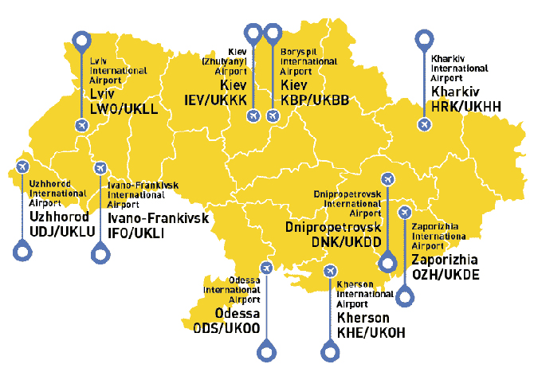
Figure 2.1 – Map of Ukrainian airports
Thus, air travel has a number of features compared to other transportation services. This is due, above all, to their dependence on weather conditions and the terrain at take-off and landing points (especially for aircraft). In addition, the operating conditions of the rolling stock force the airports to move outside the settlements and require considerable time to prepare passengers for direct flights. However, due to the main advantage of the high speed of delivery to the destination of air transportation, they pose serious competition to land and water modes.
2.2 Main local documents regarding airport activity
2.2.1 Air Code of Ukraine
The Ukrainian Air Code regulates the legal foundations of aviation activity. State regulation of activity and use of airspace provides a guarantee of safety of aviation, interests of the state, needs of the economy, needs of society, national security in aviation works and air transportation. The Air Code came into force on September 16, 2011 and consists of 20 sections (Fig 2.2).
Figure 2.2 – Air Code of Ukraine
The Air Code specifies that aviation is divided into state and civil. Civil aviation functions to meet the needs of citizens and the state in air transportation and aviation work, as well as for private flights. Civil aviation, in turn, is divided into general aviation and commercial aviation. State aviation is aimed at ensuring the defense of the state, national security and protection of the population by the Armed Forces of Ukraine and other military formations.
An airport operator should provide for the acceptance and dispatch of aircraft, the organization of ground handling of aircraft, passengers, crews, luggage, cargo and mail, must have an aerodrome, facilities, equipment, equipment, personnel and may include facilities located on its territory: air traffic management systems, meteorological services, helicopters, driveways with strips, social facilities and other structures and facilities [9].
In the case of international flights at the airport, customs, border, sanitary and quarantine and other controls provided for by the legislation of Ukraine must be carried out.
A passenger feedback system with its administration should be established at the airport to respond promptly to passenger complaints.
In order to speed up and simplify customs and border clearance procedures, an air carrier or operator of an airport or ground-handler have to send to the border guard and revenue and toll bodies operating at points of entry for air traffic, preliminary information about crew members , passengers, import, export and transit cargo carried by aircraft. The procedure, manner, form and terms of submission and storage of such information can be jointly determined by the State Border Protection Authority of Ukraine, the central executive authority, which must ensure the formation and implementation of the state tax and customs policy and the authorized body for civil aviation.
If the capacity of the airport meets the demand of the airlines and provided the proper level of service of flights of such airlines, the airport is determined uncoordinated. Slot regulation at an uncoordinated airport is performed by the airport operator.
If an airline's demand for flights to or from an airport or for flights to such an airport exceeds its airport capacity and / or production capacity, the competent civil aviation authority needs designate that airport in a coordinated manner and appoint an airport coordinator(s).
An airport may be declared coordinated for a period of time necessary to bring the capacity of the airport into line with the load and demand for its services.
A Coordination Committee must be set up to represent the interests of the parties properly and to resolve issues related to the coordinator's activities. The Coordinating Committee may be designated for more than one airport.
An airport coordinator is a legal entity that is functionally and financially independent of the airport or users of that airport. The financing of the activities of the Airport Coordinator should be provided at the expense of the State Specialized Fund for the Financing of National Expenditures on Aviation Activities and Ukraine's Participation in International Aviation Organizations.
The procedure for determining the airport coordinated, the selection, appointment of the coordinator, its activities, the process of allocation and allocation of slots for air carriers, the supervision of the coordinator, the action in case of cancellation of coordination at the airport will be established by the aviation rules of Ukraine.
The airport operator is responsible for the organization of flight safety, aviation security, ground handling, search and rescue and firefighting operations in the event of an emergency or emergency with aircraft at the airport and in the aerodrome area, effective provision services to airport users.
An operator of an airport (aerodrome), runway might take measures to prevent the aircraft from taking off on the basis of a state inspector's report on the inspection made within the powers.
An airport operator may simultaneously be an aerodrome operator.
The airport operator may independently provide services at the airport and, under contractual terms, transfer the right to ground service at the airport to legal or natural persons who meet the requirements of the aviation rules of Ukraine.
The aerodrome operator is obliged to provide the aircraft operators with meteorological information on their own or on contractual terms in accordance with the aviation rules of Ukraine.
The aerodrome operator, airport operator needs to have the right to refuse to execute an instruction which may lead to violations of the rules of flight safety or aviation security. In such a case, the aerodrome operator informs the reason for the refusal of the authority or supervisor who issued the order.
The airport operator must provide security. In order to advise aviation entities at airports and to properly represent the interests of the parties regarding the conditions of use of airports, the activities of ground handling organizations at airports, airport committees are set up under the direction of the airport operator, comprising representatives of the airport operator, air traffic services air carriers for which the airport is the base or their representative organizations, as well as representatives of the entities operating at the airport. The Civil Aviation Authority may, where necessary, send a representative to participate in the work of that Committee.
In the case of provision at airports of services of take-off and landing of aircraft, passenger service at the airport, aviation security, search and rescue in the area of ​​responsibility of the airport, the provision of over-parking, cargo maintenance, ensuring reception, storage, quality control and the issuance of aviation fuel for refueling of aircraft and in the provision of other services related to airport operations, airports and civilians Airports are charged for providing such services.
The amount of payment for the provision of aircraft take-off and landing services, passenger service at the airport terminal, aviation security, provision of over-parking (airport charges) and other services provided by the airport (airport) to users have to be established in accordance with the legislation of Ukraine. The procedure for calculating the fee for airport services and other services provided at airports (at airports), the procedure for payment and exemption from it must be determined in accordance with the legislation of Ukraine and the standards and recommended practices of the International Civil Aviation Organization.
2.2.2 Customs Code of Ukraine
This document involves all the important issues for customs control rules and principles. Its appearance you can at Fig. 2.3. The established procedure and conditions for the movement of goods across the customs border of Ukraine, their customs control and customs clearance, application of mechanisms of tariff and non-tariff regulation of foreign economic activity, customs clearance, maintenance of customs statistics, exchange of customs information, conduct of Ukrainian classification of foreign economic activity in accordance with state control of non-food products during their import into the customs territory of Ukraine, prevention and counteraction to smuggling, fight against time for customs regulations, organization and activities of bodies income and fees and other measures aimed at implementing the state customs policy, are customs [10].
Figure 2.3 – Customs Code of Ukraine
Customs is based on the following principles:
- the exclusive jurisdiction of Ukraine in its customs territory;
- the exclusive powers of the bodies of revenue and duties of Ukraine in the implementation of customs;
- the legitimacy and presumption of innocence;
- a single procedure for the movement of goods, vehicles through the customs border of Ukraine;
- facilitation of legitimate trade;
- recognition of the equality and lawfulness of the interests of all economic entities, regardless of ownership;
- observance of the rights and interests protected by law of persons;
- the promotion of integrity;
- transparency;
- responsibilities of all parties to the relations governed by this Code.
Territory of Ukraine, territorial sea, inland water and airspace, as well as territories of free customs zones, artificial islands, installations and structures established in the exclusive (maritime) economic zone of Ukraine, to which the exclusive jurisdiction of Ukraine extends, constitute the customs territory of Ukraine.
The customs value of goods moving across the customs border of Ukraine is the value of goods used for customs purposes, based on the price actually paid or payable for those goods.
The customs value of goods is used to:
- accrual of customs payments;
- application of other measures of state regulation of foreign economic activity of Ukraine;
- maintenance of customs statistics;
- the calculation of the tax liability determined by the results of the documentary audit.
2.2.3 Law of Ukraine About the State Aviation Security Program of civil aviation
State Civil Aviation Security Program designed in accordance with the conventions on international civil aviation, to combat the illegal hijacking aircraft, fighting unlawful acts against civilian safety about crimes and certain other acts perpetrated on aircraft board, and plastic markings explosives to detect them, as well as others international acts [11].
The program takes into account the requirements of the United Nations Security Council for joint efforts to prevent and stop terrorist acts.
The purpose of the Program is to create the legal foundations on aviation security and efficiency civil aviation.
The main objective of the Program is to implement activities with ensuring the protection, security and safety of passengers, crew members, aviation personnel, aircraft, facilities of airport and radio navigation facilities regardless from their ownership and subordination.
Maintaining an appropriate level of aviation security carried out in the following main directions:
- no aircraft on the state register civilian aircraft cannot depart in the absence documents giving the right to conduct business and commercial activities in the field of civil aviation;
- no person or vehicle can enter or stop in controlled, sterile and restricted areas without bypasses and security controls;
- no person may be admitted on board the aircraft without proper permission;
- items and equipment, as well as carry-on luggage, luggage, cargo, courier and postal items cannot be stocked taken aboard an aircraft without passing control on security;
- when performing aviation work at temporary airfields aviation security rests with the commander the aircraft or the person designated by the operator;
- legal entities whose activities are related to security aviation security must have the appropriate certificate;
- aviation personnel and other specialists (persons) whose work concerns aviation security, may be allowed to perform such work only on the basis of a certificate (certificate);
- international air services agreements concluded by Ukraine with other states, should contain aviation security requirements in accordance with International Organization standards and recommendations of civil aviation;
- cooperation of Ukraine with other countries on issues prevention, prevention of acts of unlawful interference with activities civil aviation of Ukraine beyond its state border is carried out on the basis of agreements on cooperation in the field aviation security.
In the aviation security program of an aviation entity determine the measures for the protection of passengers, crew members, luggage, cargo, courier and mail, board supplies, ground personnel, aircraft and services ensuring the operation of the operator from acts of unlawful intervention. The personnel structure of the aviation entity is introduced post of Deputy Head of Aviation Security, candidacy
2.2.4 Law of Ukraine About Passport control
This document introduces main principles for passport control on the border. First of all, regime at border crossing points - the procedure for finding and moving all persons and vehicles within the territory of border railway and motor stations, seaports and river ports, airports and airfields open to international traffic, as well as other activities related to a pass through the state border of persons, vehicles and cargoes, which is established by the order of the chief of the state border protection body, agreed with the body of revenue and fees and the head of the enterprise, on the territory of which the border crossing point is located.
Border control - state control exercised by the State Border Service of Ukraine, which includes a set of actions and a system of measures aimed at establishing legal grounds for crossing the state border by persons, vehicles and moving goods through it.
Border control should be carried out in order to counter the illegal movement of persons across the state border, illegal migration, trafficking in human beings, as well as the illegal movement of weapons, drugs, psychotropic substances and precursors, ammunition, explosives, materials and objects, prohibited through the state.
Border control should be carried out on:
- persons crossing the state border;
- vehicles transporting persons and goods across the state border;
- goods moving across the state border.
Border control includes:
- verification of documents;
- inspection of persons, vehicles, cargo;
- fulfillment of the orders of law enforcement bodies of Ukraine;
- verification of the fulfillment by the foreigners, stateless persons of the conditions of crossing the state border in case of entry into Ukraine, exit from Ukraine and transit passage through the territory of Ukraine;
- registration of foreigners, stateless persons and their passport documents at the border crossing points;
- inspection of motor vehicles with the purpose of finding stolen goods.
Border control is ensured by:
- establishing a regime at border crossing points and monitoring its compliance;
- the use of technical means of border control, the use of service dogs and other animals;
- creation and use of databases on persons who crossed the state border, committed offenses that are not allowed to enter Ukraine or temporarily restricted the right to leave Ukraine, about invalid, stolen and lost passport documents, as well as other statutory databases data;
- surveillance of vehicles and, if necessary, their escort;
- implementation of administrative-legal as well as operational-search measures;
- organizing and ensuring cooperation with enterprises, institutions and organizations whose activities are related to international communication;
- coordination of actions of control bodies and services.
2.2.5 Order № 407 from the 13th of June 2006 by State Department on Aviation Security of Ukraine “About Approval of Rules of certification of airports”
The rules are used for technological certification processes, production structures, organizational and technical systems and means of production to confirm their compliance to requirements of current legislation and normative documents of Ukraine, aimed at ensuring the safety of flights, aviation security, environmental safety, and occupational safety at reception facilities and aircraft departure, maintenance of air transportation and aviation works [14].
The Rules apply and are obvious for the legal persons or subdivisions of legal entities, regardless of their forms of ownership and departmental ownership that carry out the activity at the airports of Ukraine.
The State Aviation Department of Ukraine regulates activities at the airports through certification and regular process inspection of technical and ground support activities of flights with appropriate restraint or termination of activity in case of non-compliance with the requirements specified in the CA.
The airports as entities that exercise perform some types of airport activities in accordance with established Ukraine's aviation rules requirements for technological processes, organizational systems, production structures, qualifications for personnel responsible for failure to comply with these requirements.
The purpose of the applicant's certification examination is receiving confirmation that it is certified with requirements, and the supporting documentation provided, reflects the actual status and the activity of the company under all parameters, characteristics, objects and systems.
The main criterion for conformity of the technology of airport works is the absence of regular delays in the flight of the aircraft due to violations fault and ground handling technology from their fault as well no complaints about the airport from passengers, airlines or crews serviced. Staff conformity assessment is conducted through study of the staffing of the airport approved by the manager, and supporting documents containing the necessary calculations that prove the possibility of secure and quality technology works.
Completeness of actual employees are evaluated through job posting and evaluation of the impact of their lack of employment on the quality of services provided, safety and security regularity of flights. Provision of airport by qualified personnel is determined by checking the personal files of employees for the purpose identification of persons of engineering structure without profile higher education and workers with poor qualifications, violations of time recertification of employees.
Buildings and structures are considered appropriate certification requirements, if their area, technical conditions and sanitary and hygienic working conditions are in full compliance with the indicators regulatory and regulatory documents, which is agreed with the designated authority aviation security of civil aviation.
2.2.6 Order № 636 from the 18th of December 2018 by the Ministry of Infrastructure of Ukraine “About Approval of Ownership Policy of State Enterprise "Boryspil International Airport”
This document defines:
- Main objectives and priorities according to which state owns Boryspil International Airport.
- Main principles and mechanisms of control of the airport.
- Expected results of enterprise activity in the future.
The enterprise is controlled by the government through Executive department (Ministry of Infrastructure of Ukraine) with the aim of satisfaction of economics and social demands in providing with necessary services for passenger and cargo transportation, maintenance and using objects of national infrastructure and performing other tasks [13].
Main airport objectives can be divided on commercial and non-commercial. Commercial tasks of the airport include:
- Providing the service of ground handling for aircraft, flight crew.
- Providing the safe take-off-landing procedures, aircraft parking, aviation security.
- Non-commercial objectives are the following:
- Activity connected with usage of Ukrainian radiofrequencies and directed on providing effective occupation of this resource.
- Radio implementation organization, normal work of radio communication and other equipment, control of its technical state, compliance to rules of exploitation.
- Work execution for light provision for flights and the whole activity of the airport.
- Performing of meteorological provision for the activity of airport and its coordination, work control of meteorological equipment and assistance to hydro-meteorological service.
- Building control of near-airport area: if present, correct work of day and night marking, acceptance of projects of different kinds of constructions that can be obstacles for flights.
- Handling of security systems, projecting of measures for firefighting and safe heating systems, rating of objects’ fire condition.
The State as founder and owner performs control in according to such common principles:
- Exclusiveness of national ownership.
- Defining of exact aims for activity of airport.
- Priority in regulation of national and private companies, except id activity which is forced by non-commercial objectives.
- Function division of state departments on functions of owner and functions of regulator.

CONCLUSION TO CHAPTER 2
There are a lot of documents for airport activity regulation. Of course, the majority of them are based on ICAO, IATA and other organizations requirements, but there some features that are applied due to Ukrainian local regulations.
Ukrainian documents can be divided into 3 categories by legislation levels:
- Codes – they are agreed by Parliament (Air Code, Custom Code).
- Laws – they are agreed by Ministries (Law of Ukraine About Passport control, Law of Ukraine About the State Aviation Security Program of civil aviation).
- Orders – they are agreed by local responsible organizations (Order № 407 from the 13th of June 2006 by State Department on Aviation Security of Ukraine “About Approval of Rules of certification of airports”, Order № 636 from the 18th of December 2018 by the Ministry of Infrastructure of Ukraine “About Approval of Ownership Policy of State Enterprise "Boryspil International Airport”) .
The main publication regarding airport functioning is Air Code of Ukraine, it regulates the legal foundations of aviation activity. It provides an instructions for domestic and international flights of civil aircraft in international and national airspaces in order to ensure their efficiency and safety.
The Custom Code, Law of Ukraine About Passport control, Law of Ukraine About the State Aviation Security Program of civil aviation are documents that are basically applied at Boryspil airport, as they define procedures at controls points, which have influence on passenger flow.

CHAPTER 3
ANALYSIS OF PASSENGER SERVICE AT BORYSPIL INTERNATIONAL AIRPORT
3.1 History of Boryspil International Airport
An airport is an advanced aerodrome, mainly for commercial air transport. Airports often have aircraft storage and maintenance facilities as well as control towers. An airport consists of a landing area that has an open space containing at least one operationally active surface, such as an airplane take-off runway or helipad, and often has adjacent structures such as control points, hangars and terminals. Larger airports may have: platforms, bridges over taxiways, air traffic control centers, passenger facilities such as restaurants and lounges, and emergency services.
An airport serving exclusively helicopters is called a helicopter. The airport for the use of seaplanes and amphibious aircraft is called the seaplane base. Such a base usually contains an area of ​​open water for take-off and landing, as well as docks for tethering hydroplanes.
The International Airport has additional facilities for customs and passport control, as well as all the above components.
Airports are part of air transport system, because they play important role not only in transport economy, but in process of quality of life improvement by creation of its prosperity. Airports are leaders in industry, economy, tourism and commercial activity.
Due to the jet aviation development in the end of 1950s requirements for infrastructure quality has also increased. The government of USSR and general aviation was asked question about building airport, which could be able to serve airplanes weighting more than 100 tones. As alternate option airport Zhuliany was considered for reconstruction but it was decided to build a new airport near Boryspil Air Force complex, in order to comply with security requirements and expand area available for airport. Also the significant argument was that at Boryspil aerodrome already had a runway with hard surface and also there was a high way from and to Kyiv, which resolved infrastructure problem.
After authorizing the deployment of civilian aircraft at the military aerodrome, the airport's preparation for the opening was quite rapid. Construction work was carried out around the clock.
Initially, it was planned that the passenger service would be divided into tiers, and a telescopic ladder gallery would be built. However, the gallery was abandoned due to unresolved issues with the manufacture of the latter, and passenger service (arrival and departure) was decided to perform on the first floor at the platform level.
In May 1959, the Council of Ministers of the USSR adopted a decree on the creation of the Boryspil military airfield at the Kiev (Central) Air Fleet Airport and decided to provide it with modern aircraft, ground equipment and radio equipment.
On June 30, 1959, the Chief of the Main Directorate of the CPF (Civil Air Fleet) signed Order No. 265 on the creation of the airport.
On July 7, 1959, the first flight was accepted. It was carried out by the crew of the Moscow Civil Aviation Administration on the Tu-104 on the route Moscow - Kiev - Moscow. There were 100 passengers on board (mainly aviation executives and journalists) and 1,600 kg of cargo. In the first year, the activity was carried out in field conditions (six tents), and subsequently - in temporary premises. However, in such a short period Boryspil Airport came in third place in terms of passenger traffic among Ukrainian airports (after Simferopol and Zhulian airports).
From July 10, 1959, the Tu-104 flights became regular. Until November 1960, flights to the Kiev (Central) airport were operated by crews of the Moscow, Leningrad and Georgian civil aviation departments.
In 1960, Boryspil Airport began to take international flights to Budapest, Vienna, Sofia. The same year a squadron No. 208 of the Tu-104 and An-10 turboprop aircraft was united at the base of the An-10 squadron, united with the Boryspil airport.
1961 - the Kievproject Institute develops the project of the airport terminal. Construction of the new terminal in Boryspil took three years. Zero work started at the same time around the perimeter of the terminal. The ground part was built in two stages: first, the left and right wings were built, then construction of the central part under the dome began. The project at the time involved an area of ​​20,300 m2. The length of the terminal was 230 meters, width - 50 meters, volume - 107 500 m3, capacity during the peak - 1600 passengers per hour [5]. The main component of the terminal is the space under the dome. It consists of concrete slabs each measuring 8.1 2.6 m weighing up to 7 tons. To raise the plates, the crane had to be installed on an earth embankment 7 meters high. Inside the ceiling is covered with 1100 special acoustic panels (weight of each - 80 kg).
In 1963, the Boryspil United Air Force was organized, which included the Boryspil Airport and Flight Squadron No. 208. In 1971, the Second Flight Squadron, No. 222. was organized as part of the Boryspil United Air Force Squadron - No. 222. As of 1974, Flight Squadron No. 208 It consisted of three Tu-134 and Tu-104 turbojets, and flight unit 222 of two Il-18 turboprop aircraft and Tu-154 aircraft squadrons.
On May 20, 1965, a new Boryspil Airport was opened. Boryspil Airport was equipped for the automated landing of aircraft at category 1 meteo-minima. At the time, the capacity standards were 1,400 passengers on domestic and 200 on international flights. The airport was the second largest after Domodedovo Moscow Airport and one of the largest in Europe. The Muscovites called the Boryspil Terminal "Covered Market", instead Ukrainian aviators called the Domodedovo "Konyushnya".
1971 - Opening of the second runway 18R / 36L 3.5 km long. As the number of passengers increased, there was a need to build an additional runway. In addition, a radio-electric workshop, a laboratory building of the ATB, an emergency rescue station, a complex of secondary radar facilities were built.
1982 - construction of the center of the automated air traffic control system in Ukraine "Arrow". It facilitated the work of air traffic controllers and crews and covered virtually the entire territory of Ukraine.
By 1990, Boryspil Airport had the best performance among Ukrainian airports. The crisis after the collapse of the USSR affected the activities of the airport. The closure of the company was avoided due to the investors found.
In the early 1990s, the Cabinet of Ministers of Ukraine adopted a decree of historical significance for the reconstruction of Boryspil Airport. The ordinance provided that 60% of the funds would be raised from investor firms. This gave a new impetus to the development of the enterprise.
March 11, 1993 Boryspil Airport receives the status of a state international airport.
On April 1, 1993, the second legal establishment of Boryspil Airport took place. According to the order of the Minister of Transport of Ukraine, the State International Airport of Boryspil was established on the basis of Boryspil Aviation Company as a legal entity, regional directorate of Airlines of Ukraine and KyivCenter.
In 1998, ICAO President Dr. Assad Kotayt officially confirmed the status of the airport's training center as an ICAO aviation security center (as of today, this unit is one of 21 such centers in the world).
2001 - The runway 18L / 36R was reconstructed to mark the 10th anniversary of Ukraine's Independence. The money was drawn from the European Bank for Reconstruction and Development, which was the first EBRD loan in Ukrainian history. Prior to the reconstruction of the MPM liners on this runway was limited to 47 tons, but after repair here can land any type of aircraft [6], in particular An-225 and A-380. At the time of reconstruction, the 18L / 36R met ICAO Category I requirements.
In 2002, the airport received an international certificate of conformity (ISO 9001: 2000) for the implemented quality management system.
In 2013, the 36R airport runway received category IIIa approval for measures and landings in low visibility conditions - 30 m vertical and 200 m horizontal.
3.2 Basics of work of Boryspil airport
The tasks of developing the industry at the present stage are: increasing the availability of air transportation by reducing the cost of airport services, attracting airlines with various business models (low-cost fires, regional carriers), developing a route network of airports, expanding the scope of potential passengers; modernization of infrastructure to increase comfort, safety of air transportation; increasing the efficiency of using the infrastructure to meet the growth of air transportation; increasing competitiveness for the development of the transit transportation market.
A particularly difficult situation is developing in regional markets, where in a significant number of cases there has been a significant obsolescence of airport infrastructure, a violation of the existing network of interregional communications. At the same time, the availability of an airport and the availability of air transport is an important factor in developing the competitiveness of any region, ensuring social goals and stimulating economic growth due to better mobility of the population, development of the tourism sector and local business.
The development of new technologies and business methods for regional airports is an important and urgent task. Their solution involves increasing the innovative activity of companies. Innovative activity (activity) is a practical usage of scientific, scientific-technical and intellectual potential of the result is to obtain a new or improved product produced, the method of its production. Innovative activity is one of the areas of activity of any enterprise, along with production, marketing, finance, personnel development. Innovative activity is characterized by goals, means, processes, forms of organization, results.
The main goal of the innovation activity of airports is the construction of new goods (services) or goods (services) with new qualities. The means of innovation are the production and experimental facilities involved in it, material, financial resources, airport personnel. The strategic innovative goals for the development of airports can be:
- transformation into an international airport;
- attracting new customers;
- increasing the capacity;
- providing passengers with the necessary service;
- ensuring acceptable airport charges, etc.
A common property of these goals is their exceptional relevance and need for the continued existence of the enterprise, the high cost of time and money for the implementation of the developed development project. The formation of a system for ensuring the competitive advantages of the airport as a service enterprise based on innovative behavior is justified provided that the process of developing and implementing competitive innovation processes with the very beginning is properly organized. From the substantive point of view, it must be considered as the unity of the three components of the organizational structure of the enterprise, its combination of interrelated reactions to ensure competitiveness through the development of innovative activities and the organizational and economic mechanism of functioning. Such a division is consistent with the separation of three aspects accepted in the systematic approach - objective, attributive, and relational.
In the problem of building the process of formation of innovative behavior of the airport as a service industry enterprise, there are three main aspects: technical, economic and organizational. The technical aspect is the process of forming an innovative set of interrelated reactions aimed at improving the production of services, improving their consumer properties through the development of innovations in order to ensure the competitiveness of the research object.
The economic aspect is the process of forming an innovative set of interconnected reactions aimed at ensuring loss-free and profitable production, the formation of the optimal price for services, their promotion on the market and, on this basis, ensuring the desired competitive position of service enterprises. The organizational aspect is the process of creating an innovative set of interrelated reactions aimed at improving the efficiency of competitiveness management of service enterprises. Thus, the implementation of the proposed concept of creating a system for ensuring the competitiveness of service enterprises for an account of innovative behavior allows airports as service enterprises to increase the level of the quality of the services they provide, attractiveness for business partners and consumers of the services offered, the overall competitiveness rating, and hence the efficiency of the use of available resources, manifested in the positive dynamics of the main resulting indicators of business entities.
Other activities of the company are:
- ensuring the acceptance and release of aircraft;
- technical and commercial servicing of aircraft;
- service for passengers and other airport customers, receiving and sending baggage, cargo, mail;
- air security, security from unlawful interference with the airport;
- development the material base and the social sphere in order to provide a more complete socio-economic support for the labor collective;
- construction and operation of industrial and residential buildings, equipment, aprons and aircraft parking lots and each x facilities necessary for the operation of the airport;
- participation in the organization and conduct of investigations of aircraft accidents, incidents, damage to aircraft, the organization and conduct of investigations of industrial accidents, the development and implementation of measures to prevent them, as well as participation in organizing and the implementation of search and rescue operations.
Also, Boryspil Airport has the ability to organize any of its activities permitted by law upon receipt of an appropriate license for this type of activity. Airport is guided by a quality policy that provides for the following requirements:
- ensure the required level of regularity flights and an acceptable level of flight safety with continuous improvement of production processes;
- increase the quality of services provided and the efficiency of the business through the implementation of advanced technologies and the use of best domestic and international practices based on a continuous assessment of the satisfaction of air passengers and air carriers;
- to carry out the selection and involve reliable suppliers in accordance with the requirements of Boryspil Airport.
In the framework of the diploma work, we studied in detail the structure of the transportation management service (TMS), which is responsible for the organization of passenger services, and its functions. The structure of the TMS is determined in each case, based on the volume of air traffic at this airport, the presence of this the city of the city airport, in which registration of departing passengers, such as aircraft operating this airport, the presence in the airport of the international sector and other features.
At large airports, such as Boryspil Airport with significant volumes of traffic, TMS consists of several independent services (Fig. 3.1).
Transportation Management Service
Service for organizing air transport
Service for organizing postal and freight transportation
Airport service for arrangement of passenger carriage

Figure 3.1 – Transportation Management Service components.
The main tasks of all departments are following:
- A high level of regularity and safety of flights.
- Operational control of the timely execution of all technological operations.
- Clear interaction of all TMS groups and relevant airport services in case of flight delays and the occurrence of “malfunctioning” situations.
- Timely sending of transit and transfer passengers.
- Improving the economic efficiency of flights with the maximum paid commercial load of each flight.
The practice of civil aviation shows that the most successful interaction tasks are solved we are introducing a dispatching system of management and control (scheduling), in which each group is responsible for the execution of a particular operation and the dispatcher has the right to demand the execution of operations within the deadlines set by the schedules. As can be seen from the diagram, the enterprise management structure has a linear form.
A linear organizational management structure is such a structure, between the elements of which there is only one-channel interaction. This type of organizational structure refers to the rigid management structures of the organization. A linear management structure is formed as a result of constructing a management apparatus based on linear relationships in the form of hierarchical degrees. The linear structure provides for the division of the organization into interrelated departments according to various characteristics of the ongoing activity. The essence of the linear (hierarchical) management structure is that control actions on an object can be carried out only by one person - a linear manager who directly generates control decisions or transfers them from the head above in the managerial hierarchy. Each subordinate has only one leader, who performs all administrative and special functions in the corresponding structural unit. Such a structure is used in the management system of production sites, individual small workshops, as well as small enterprises with homogeneous and uncomplicated production technology (in the absence of extensive cooperation links between divisions, with suppliers, consumers, scientific and design organizations).
The advantages of the linear management type organizational structure are:
- simple structure;
- unique distribution of tasks, competencies, responsibilities;
- realization of the principle of unity of command and personal responsibility for the results of work;
- one communication channel;
- clarity, accuracy and efficiency of management decisions.
Among the shortcomings of the linear management structure, its inability to grow and develop the enterprise is usually noted. The linear structure is focused on a large amount of information transmitted from one level of management to another, limiting the initiative of workers at lower levels of management. It makes high demands on the qualification of managers and their competence in all matters of production and management of subordinates [16].
The linear management structure is mainly characteristic of organizations with small number of employees. This structural unit of the airport, like the whole enterprise, works with large arrays of documents, entering the enterprise both in paper and in electronic form. In the organization of both internal and external workflow, preference is given to its paper form, but the airport has a well-functioning electronic documentation system, without which the airport’s activities are not possible. The structure of linear management you can see below at Fig 3.2:
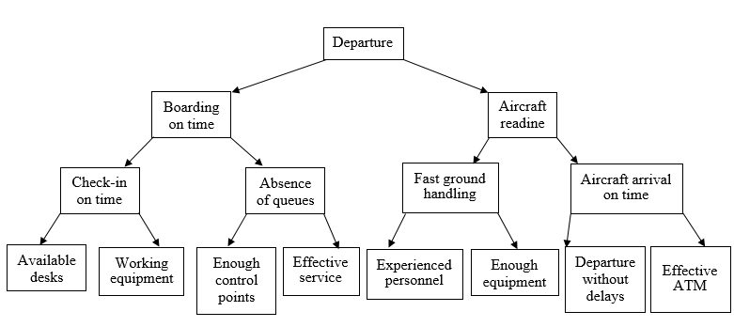
Figure 3.2 - Structure of organizational linear management
3.3 Calculation of passenger flow in Boryspil airport
Serving air passengers at airport terminals is an example of a mass service system. Systems in which, on the one hand, mass requests (requirements) arise for the fulfillment of certain types of services, and, on the other hand, these requests are satisfied, are called mass service systems.
From queuing theory it is known that each queuing system with expectation consists of the elements shown in Fig 3.3:
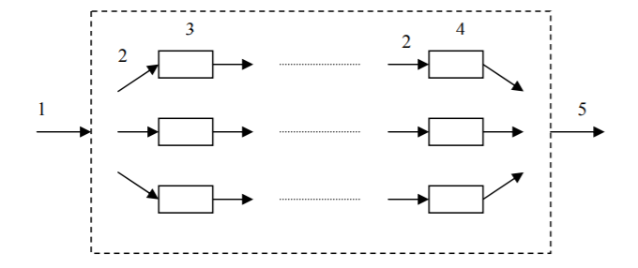
Figure 3.3 - Queuing system scheme: 1 - incoming flow; 2 - queues for service; 3 - serving devices of the 1st phase; 4 - service devices of the first phase; 5 - output flow
Queuing systems that may have any long queue of requirements for a service device are called systems with expectation.
Queuing systems are classified:
- by the number of simultaneously operating service devices (channels) - to single-channel and multi-channel;
- by the number of service phases - into single-phase and multiphase ones.
In accordance with the above classification, the airport passenger terminal is a multi-channel multiphase queuing system with an expectation, the state of which changes randomly over time.
The incoming flows in relation to the terminal are:
- the flow of passengers arriving at the airport terminal for formalities;
- the flow of passengers arriving at the airport and waiting for baggage;
- luggage flow separated from the passenger flow and undergoing multiphase service.
Service devices are:
- For the incoming flow of passengers departing from the airport, at the terminals of domestic airlines - check-in counters and special security checkpoints.
- For the incoming flow of passengers departing from the airport, at the airports of international air lines - check-in desks, security checkpoints, customs desks, passport-border, sanitary control points;
- For passengers arriving at the airport - baggage claim points equipped with various means of mechanization. In some cases, both departing and arriving passengers of international airlines pass through border, customs and sanitary controls;
- For luggage - check-in counters, sorting devices, various transport and handling equipment.
The task of studying the airport as a queuing system is to determine the optimal relationships between the characteristics of the incoming passenger flow and the number of service vehicles.
The main parameters of the passenger service system at the terminal, to be calculated when analyzing their functioning, will be:
- the intensity of the incoming flows of passengers and baggage;
- the intensity of passenger service in the operating rooms of the terminal;
- optimal number of jobs for passenger check-in and baggage claim;
- the number of baggage claim points and points for customs and border formalities at international airports.
Along with the indicated parameters characterizing the terminal as a queuing system, the parameters of the main operating areas of the airport are subject to determination:
- the capacity of the main operating areas of the airport;
- required sizes of the main operational areas of the terminal.
Let’s apply all above information to Boryspil airport. Below you can find map of the whole airport complex (Fig. 3.4, Fig. 3.5, Fig. 3.6, Fig. 3.7).
The ground floor is dedicated for arriving passengers. There are located lines for receiving the luggage, baggage claim, custom control and sanitary control is necessary.
The second level is mostly used for serving of local flights: check-in desks, aviation security points and gates. For arriving passengers there is located passport control, but it is isolated from zone for local flights.
The third level is the place with the highest intensity of passenger flow- it is zone for departing passengers with international directions.
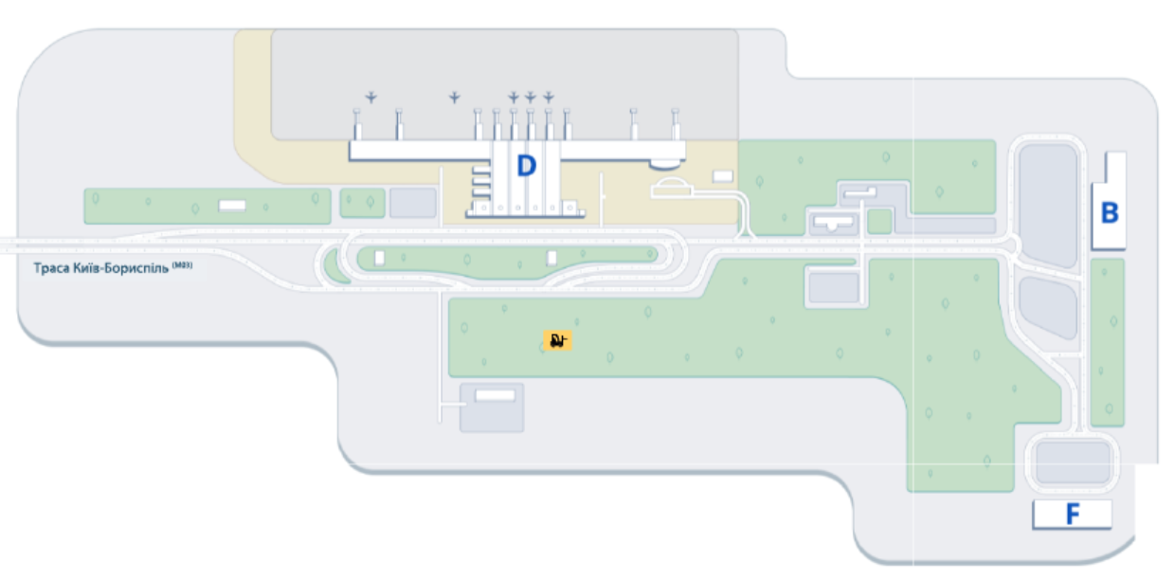
Figure 3.4 – Terminals locations in Boryspil Airport
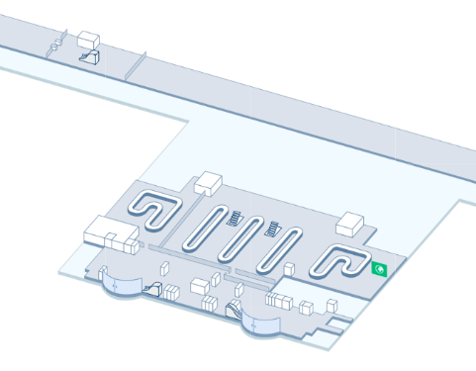
Figure 3.5 – Ground level of Boryspil Airport
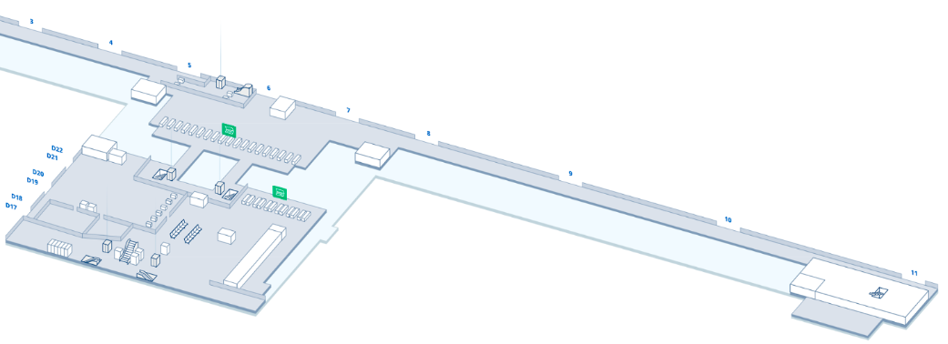
Figure 3.6 – The second level of Boryspil airport
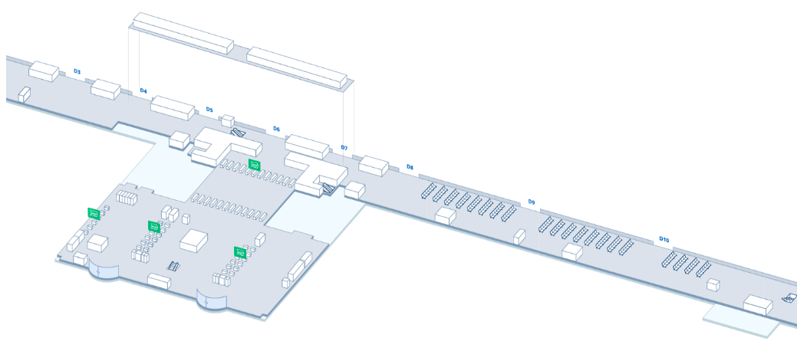
Figure 3.7 – The third level of Boryspil airport
As international routes are the most popular, that is why there are much more check-in desks, aviation security checkpoints, custom and passport control points, also there are more gates at the third level of airport.
The intensity of the incoming flow of passengers arriving at the operating hall of the terminal is a function of time and is defined as:
${\text{λ}}_{\text{flow}}\text{=}\frac{\text{dN}}{\text{dt}}$ (3.1)
Where:
$λ_{flow}$ -intensity of passenger flow; $N$ - the number of passengers served in the operating zone of the terminal; $t$ – time.
According to statistics, there is the biggest number of passengers is served per year in Boryspil than in any other Ukrainian airport (Table 3.1).
Table 3.1 – Comparison of the passenger flow in different Ukrainian airports
Rate | Airport | City | Code  (IATA/ICAO) | Passenger flow for 2018 year
1 | 2 | 3 | 4 | 5
1. | Boryspil Airport | Kyiv | KBP/UKBB | 12603271
2. | Zhuliany Airport | Kyiv | IEV/UKKK | 2812300
3. | Lviv Airport | Lviv | LWO/UKLL | 1598700
4. | Odesa Airport | Odesa | ODS/UKOO | 1446521
5. | Kharkiv Airport | Kharkiv | HRK/UKHH | 962500
6. | Zaporizhzhia Airport | Zaporizhzhia | OZH/UKDE | 400326
7. | Dnipro Airport | Dnipro | DNK/UKDD | 299250
8. | Kherson Airport | Kherson | KHE/UKOH | 150100
9. | Ivano-Frankivsk Airport | Ivano-Frankivsk | IFO/UKLI | 112607
10. | Chernivtsi Airport | Chernivtsi | CWC/UKLN | 72973
Applying the formula 3.1 to KBP we will get such result:
$λ_{flow}=\frac{12 603 271}{365}=34 530$
12603271 – is number of all passengers served in 2018 year;
365 – number of days in 2018 year.
As a result, we understand that in average, 34 530 passengers were served daily.
Thus, the magnitude of the intensity of the incoming passenger flow is determined by the following main factors: traffic intensity at the airport, the passenger capacity of aircraft operating flights for which registration is made, the number of flights for which registration is simultaneously made.
Passenger service at the airport terminal is a multiphase process, the set and sequence of phases of which depends on the following factors:
• type of transportation. Serving passengers on international airlines requires a much larger number of operations than domestic ones;
• categories of passengers. Departing passengers go through different stages of service than arriving passengers;
• service technology adopted at a specific airport.
Depending on the airport in question, the stages of ticket registration and screening may change places; check-in methods used, etc.
The intensity of passenger service during check-in in the operating room of the airport terminal is one of the important characteristics that determine the throughput capacity of the ground-based passenger service system transport.
The intensity of passenger service at airports at check-in counters is determined by the composition of the operations performed and the average time to complete them. The calculation of the intensity of service is performed according to the formula:
$ν= \frac{1}{M\left[T_{serv}\right]}$ (3.2)
where: $ν$ – intensity of passenger service; $M\left[T_{serv}\right]$ – average time of passenger service in the terminal, min.
The service time at airports is a random variable depending on the composition of the formalities to be performed, the organization of work, the number of tickets registered and the baggage space of each passenger. Average duration of airline passenger service:
$M\left[T_{serv}\right]= t_{1}+t_{2}+t_{3}+t_{4}+t_{5}+t_{6}+t_{7}+t_{8}$ (3.3)
Where:$t_{1}$ - time necessary to; $t_{2}$ – time necessary to find in the check-in system passenger’s details; $t_{3}$- time necessary to remove hand luggage from the scale; $t_{4}$- time necessary to put into the system data about passenger’s baggage; $t_{5}$- time necessary to print boarding pass and baggage tags; $t_{6}$- time necessary to stick baggage tags; $t_{7}$- time necessary to inform passengers about flight details, to give to them boarding passes and baggage tags; $t_{8}$ – time necessary to put the baggage to transporter line.
The average passenger service time at the airport terminals of domestic airlines is 35-70 seconds for various airports. The distribution of the average service time at the Boryspil International Airport by operations is shown in Table. 3.2.
Table 3.2 - distribution of the average service time at the Boryspil International Airport
Operation name | Calculation | Duration, sec
Getting a ticket and setting baggage on the scale. | $$t_{1}$$ | 10
Removing hand luggage from the scale, to putting the baggage to transporter line. | $$t_{3}+t_{8}$$ | 15
Sticking baggage tags. | $$t_{6}$$ | 5
Putting into the system data about passenger’s baggage. | $$t_{4}$$ | 10
Putting into the system passenger’s details, giving instructions and boarding passes. | $$t_{2}+t_{5}+t_{7}$$ | 20
Duration of service | $$ν$$ | 60
It should be noted that when servicing passengers on international lines, the average service time increases significantly. This is due to the need for the passenger to go through additional service stages such as customs and border formalities. Data on the duration of passenger service for international flights in airport “Boryspil” are given in Table 3.3.
Table 3.3 - Duration of passenger service for international flights in airport “Boryspil”
Service phase | Service duration, sec
Check-in | 60
Aviation security check | 80
Custom control | 60
Passport control | 60
Total service time | 260
So the intensity of passenger service at International Airport Boryspil is 0.23 passenger per minute.
$ν= \frac{1}{M\left[T_{serv}\right]}= \frac{1}{4.33 min}=0.23$
CONCLUSION TO CHAPTER 3
As we have investigated in the Third Chapter from a technological point of view, airports are complex of structures that ensure the arrival and departure of passengers, baggage, mail and cargo, the organization and maintenance of aircraft flights.
One of the most important technological elements of the airport is its airport complex, designed to serve all categories of passengers, meeting and seeing off people, as well as casual visitors. The main categories of passengers served at the airport:
- initial - passengers starting their movement at the airport;
- final - passengers completing their movement at the airport;
- transfer - passengers who transfer from an airplane of one flight to an airplane of another flight to continue on the route of transportation;
- transit - passengers making a short stop at the airport, following the route further on the same flight with which they arrived at the airport.
The technological service schemes adopted at major domestic and foreign airports, except for the indicated persons, provide for the presence at the terminal of crew members of aircraft, as well as employees of the airport and airlines. So at the airport Boryspil the average duration of passenger service is 260 sec. This time can be reduced by the measures described in the next chapter.

CHAPTER 4.
EFFECTIVE WAY TO IMPROVE THE PASSENGER FLOW
4.1. General information about Passenger Flow Measurement
Boryspil Airport is the largest international airport of Ukraine, which provides about 65% of Ukraine's air passenger traffic and is the base for the leading Ukrainian airlines.
The airport is located at the intersection of many air routes that connect Asia with Europe and America. About 50 national and foreign airlines operate passenger and cargo transportation from Boryspil on more than 100 regular routes.
For many, the most stressful part of air travel is the waiting at the airport. Crowded terminals and longer queues and wait times for check-in, security, customs, baggage claim, and even taxi queues quickly turn anxious travelers into frustrated passengers. With global air traffic on the rise - the International Air Traffic Association estimates the current volume will double by 2035 - airports are scrambling to deliver high quality service and an exceptional experience to ensure travelers choose them instead of a competitor airport.
With air travel increasing, airport operators who cannot expand their infrastructures due to environmental issues, space restrictions, or lack of capital must find new approaches to be more efficient and responsive to passenger needs. Airports around the world, from international hubs to regional airports, are focusing on how to deliver high quality service and a pleasing experience to ensure passengers choose them instead of a competitor airport. While flight delays and cancellations can be beyond an airport operator’s control, the ability to get ahead of issues, such as long queues, before they derail a passenger’s journey, can create more than a competitive advantage for an airport. According to an industry survey, an extra 10 minutes spent in a security queue reduces a passenger’s spending on retail by 30 percent on average. Thus, managing queues and flow also becomes an important tool to generate more non-airline revenue for an airport. What is needed to deliver the best possible passenger experience involves having a deep understanding of passengers and their journey through airport. When do they arrive? How long are they standing in line? Where do they spend time once they are past security?
Today, there are a range of technologies that can help airports answer these questions and deliver improved outcomes for passengers, partners, and their own business. Using measurement sensor technologies, airport operators can monitor passenger volumes, journey times, and queue times; establish performance baselines; track progress against key performance indicators; and derive a wealth of information on passenger habits and their experience as they journey throughout the airport campus. When these technologies are combined with historical data and current situational data, airports can compare forecasted demand to actual conditions to generate new forecasts. This solution provides operators a better understanding of expected passenger flow and early warning of where resources should be deployed to prevent bottlenecks caused by unexpected circumstances.
Many airports have implemented a Passenger Flow Measurement or Queue Measurement System (QMS) to track and quantify the number of passengers waiting in line and for how long. Some airports are even using this data to display estimated wait times and keep passengers calm. In this chapter we analyzed the shortcomings for airport Boryspil using a Passenger Flow Management approach that can help airports optimize wait times, reduce overhead, maximize revenue, and improve the overall passenger experience. It also highlights sensor technologies that can be implemented to further understand passenger volume and activity and improve the passenger experience [19].
4.2. Main principles of Passenger Flow Measurement system
No one sensor or type of technology can meet all of an airport’s passenger measurement requirements. By adopting a Passenger Flow Management solution that is flexible and will meet both immediate and future needs. What follows are leading sensor and tracking technologies to consider when designing PFM platform.
- Wi-Fi tracking sensors: With the ability to capture signals from smartphones, tablets, and laptops, Wi-Fi device tracking technology is one of the most effective and economic ways to facilitate queue measurement, passenger tracking, and dwell time monitoring throughout an airport.
- Video-based analytics: Video-camera based people counting uses image processing techniques to detect people as “moving targets.” As people move through the picture, the image processing engine compares frames to detect movement and as people cross lines, they can be counted in and out of areas.
- 3D stereoscopic tracking: Stereoscopic cameras—specialized cameras with 3D stereo lenses —can hold an identifier for a passenger in 3D, enabling it to detect, track, and count passengers with high accuracy and reliability, even in high traffic environments and environments where high location accuracy is required (nearby check-in desks and nearby mixed passenger flows).
- Thermal image counting: Thermal image counting works by detecting the heat emitted by people passing in the area beneath them as infrared radiation. With no physical alignment, calibration, or scene specific setup requirements, the counters can be installed very rapidly and at relatively low cost (Fig 4.1).
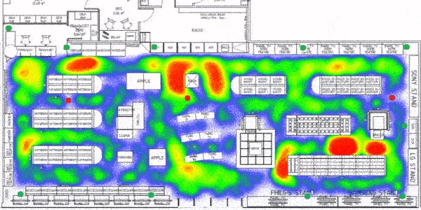
Figure 4.1 – Queues at the airport depicted by thermal image camera
- Facial recognition tracking: As technology advances, so does the ability to measure and track people via a variety of biometric-based tools. Real-time facial recognition registers a passenger as they enter a specific point. Their face is detected by a camera and a snapshot taken.
There are a number of sensor technologies available to help you understand the flow of passenger movement. Ultimately, technology selection should be based on what needs to be improved (and therefore measured), and where that measurement should occur. As no single sensor technology can meet all the needs of an airport, business requirements and physical environment need to drive the design of the measurement ecosystem.
You should also select technologies that meet airport’s current needs, as well as support future improvement opportunities. A sensor agnostic platform, as opposed to single-type sensor solutions, provides a greater ability to integrate multiple sensor technologies and existing data sources into a single analytics and dashboard platform. This should be a key consideration when evaluating technologies.
Additionally, do not overlook opportunities to integrate existing, disparate systems such as car park management, check-in systems, X-ray, archway metal detectors. Many of these existing systems can provide a wealth of data and supporting information to improve the passenger experience, and impact whether new technologies and supporting systems are even needed. Before designing a PFM platform, existing sensors, systems, and projects should be inventoried and examined to understand the depth of data already available throughout the airport [20].
4.3 Advantages of PFM
Main pros of extensible Passenger Flow Management solution include:
- Measurement technology that is non-intrusive, privacy-protected, flexible, market leading, tried and tested, and highly accurate.
- Ability to forecast in real-time as new information becomes available on the day of operations to remove the impact of flights off schedule, bad weather, traffic conditions etc.
- Capability to forecast passenger flow and analyse airport capacity years, months, days ahead.
- Strong, extensible analytics platform that can scale up or down the number of measurement use cases and introduce multiple measurement technologies in future years.
- Provide one clear “single pane of glass” view of the overall terminal performance, allowing an airport to make the right decision at the right time (Fig. 4.2).
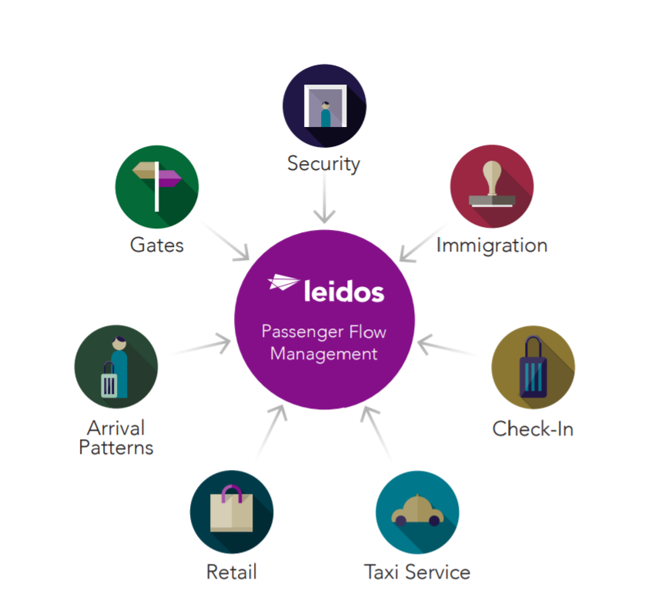
Figure 4.2 – Stakeholders of PFM
Airports are taking advantage of this combined solution— appropriately called Passenger Flow Management (PFM) to improve situational awareness and enable proactive decision making [21]. Immediate benefits of PFM include:
- Metrics allow continuous improvement in operations as demand changes, helping improve planning and reduce congestion at common passenger pinch points such as check-in and security.
- Passenger flow data can be used by analytical systems, allowing processes to be adjusted to accommodate demands.
- Real-time data can be pushed to public messaging displays and third-party applications to improve passenger communication.
- Data on passenger volume supports management of maintenance and government agency contracts.
- Sharing this information with stakeholders, including airport staff, immigration, and security agencies, retailers, contractors, and planning departments, helps them avoid bottlenecks in their respective areas and improves airport efficiency.
4.4 Limitations of Passenger Flow Management
Despite ability to present airport operators with real-time and historical queue time and passenger volume data, QMS and Passenger Flow Measurement systems are not a perfect feature for improving the passenger experience. In fact, airports who only implement a measurement system face a number of limitations:
- Lack of Predictability: Many QMS and Passenger Measurement systems only give an airport part of the operational situation - that they have a queue. Unfortunately, by the time a line has formed the passenger experience has already been compromised. Utilizing a measurement system without near term predictability limits an airport operator’s ability to make quick, informed decisions on how best to allocate fixed resources (lanes, check-in counters, etc.) and non-fixed resources (customs officers, customer services staff, etc.) to improve the passenger experience.
- Lack of Comparison with Terminal Performance Plan: Utilizing a QMS and Passenger Measurement systems without an overall integrated picture of the current terminal plan performance, or how the plan compares to predicted passenger flow outcomes, limits an operator’s ability to understand the situation. Why did we have a queue and how do we avoid it in the future? Were there too few lanes open? Did more passengers arrive than expected? By comparing actual passenger flow measurement and lane/ desk status with the forecast plan, an operator can continually improve operational performance.
- Lack of Flexibility: Experience from airport-wide passenger flow measurement implementation has found that no single technology can meet all airport needs. Often, measurement technology designed for one specific airport area may not work correctly for another. For example, technology that works for a security checkpoint may not be optimal or operate correctly for a check-in area. Furthermore, measurement technology can be inflexible and not operate accurately across multiple, different areas of an airport due to environmental conditions (light, heat, physical obstacles) or economic limitations (large infrastructure requirements).
- Lack of Integrated Analytics Platform: Implementing a measurement system that is not integrated within an enterprise business intelligence and analytics platform limits data access. Without an integrated, data-driven picture of terminal performance limits, airport operators are less equipped to make quick, informed decisions and to effectively share data with stakeholders inside and outside of the airport.
- Lack of Extensible Platform for Passenger Management: Without an extensible platform an airport cannot easily take advantage of opportunities to extend passenger measurement to new airport areas or use cases, such as taxi ranks, car parks, approach roads, etc. Being tied to a single or small number of sensor types or vendors also restricts airport operators’ ability to take advantage of new technologies in the future.
CONCLUSION TO CHAPTER 4
Airport Boryspil has problems with passenger flow, lines have to be decreased in order to make airport functioning more effectively. That is why queues problem must be solved. We discovered Passenger Flow Management System that is implemented in the majority of large airports of United States of America, for example: John F. Kennedy International Airport in New York, Hartsfield–Jackson Atlanta International Airport, O’Hare International Airport in Chicago and Dulles International Airport in Washington D.C.
The PFM is an integrated systems which consists of different systems for queues prevention and measurement, such as: Wi-Fi tracking, thermal image counting, 3D stereoscopic tracking, facial recognition tracking, and video-based analytics. The main advantage that encourages airports to use is low price for each system, but anyway it can take some time and cost to implement and join it into one system working simultaneously.
The best way to perform effective functioning of the system in airport Boryspil is to locate mentioned devices in the most crowded places, such as: check-in desks, security check points, customs and immigration controls. Each of tool will simultaneously check and fulfil the gaps of another one, is some mistake happen.
There are some limitations and error that take place in the airports in which PFM system is implemented. Airports are different from each other and some others errors can occur, but with enough amount of tools, right software installing and correct data analyzing they will be fixed.
As a conclusion we can say, that PFM is not a matchless system, it has its own limitations and disadvantages, but nevertheless, it is the optimal system for installing at Boryspil International Airport.
GENERAL CONCLUSION
Airports are vital national resources. They serve a key role in transportation of people and goods and in national and international commerce. They are where the nation’s aviation system connects with other modes of transportation and where state responsibility for managing and regulating passenger service operations intersects with the role of state and local governments that own and operate most airports.
The purpose of Diploma work is to introduce common passenger service problems, to adapt appropriate new technologies from other industries, and to implement innovations into the airport industry.
During preparing this Diploma work such results has been achieved:
- We got acquainted with current passenger service at the airport: check-in, border, customs and security controls.
- Found out pros and cons of actual system and problems that are appearing now.
- Developed main recommendations how to optimize and increase passenger flow in Boryspil airport.
ICAO and IATA documents are the most significant standards and instructions that are used at vast majority of the world airports. The main functions of these publications is to perform control of aerodromes and aircraft operation by sharing of experience of global practices. Mentioned background is used in Ukrainian airports and have an influence on local aviation legislation, as Ukraine is ICAO-member and IATA-member.
So at the airport Boryspil the average duration of passenger service is 260 sec. The PFM is an integrated systems which consists of different systems for queues prevention and measurement, such as: Wi-Fi tracking, thermal image counting, 3D stereoscopic tracking, facial recognition tracking, and video-based analytics. The main advantage that encourages airports to use is low price for each system, but anyway it can take some time and cost to implement and join it into one system working simultaneously.
In the work is presented integral approach to solve passenger service problems at Boryspil International Airport by applying new technologies for tracking the queues. Indeed, the acceptation of these innovations would not solve all the problems, but surely, it would optimize and increase the passenger flow.
The implementation of queue control systems is the first important step for solution of existing problems in Boryspil airport. The practice of installation of new features and tools can be useful experience that would be shared with another Ukrainian airports. Also the increase of passenger flow can become a significant factor for implementing another world airlines flying to Boryspil, which will also influence on increase and optimization of passenger flow.

LIST OF REFERENCES
- Doc 9652 ICAO – Airport Economics Manual [Електронний ресурс] :\ https://www.icao.int/sustainability/Documents/Doc9562_en.pdf
- Doc 9137 ICAO - Airport Services Manual [Електронний ресурс] :\ https://standards.globalspec.com/std/9999499/icao-9137-part-1
- Doc 9626 ICAO - Manual on the Regulation of International Air Transport [Електронний ресурс] :\ https://www.icao.int/Meetings/a39/Documents/Provisional
_Doc_9626.pdf
- Freedoms of the air [Електронний ресурс]:\ https://www.icao.int/Pages/4
freedomsAir.aspx
- Doc 9082 ICAO - Policies on Charges for Airports and Air Navigation Services [Електронний ресурс] :\ https://www.icao.int/publications/Documents/
9082_9ed_en.pdf
- Annex 14 ICAO – Aerodromes [Електронний ресурс] :\ https://www.flasht
echnology.com/wp-content/uploads/2017/09/ICAO-Annex-14-Chapter-6-2013.pdf
- IATA Resolution AHM-810 [Електронний ресурс] :\ http://www.swgh.
az/uploads/filemanager/AHM810_2013_SGHA-GHC.pdf
- IATA Passenger Services Conference Resolutions Manual [Електронний ресурс] :\ https://www.iata.org/en/publications/store/passenger-services-conference-resolutions-manual/
- Повітряний кодекс України [Електронний ресурс] :\ https://zakon.rada.
gov.ua/laws/show/3393-17
- Митний кодекс України [Електронний ресурс] :\ https://zakon.rada.gov.ua/laws/show/4495-17
- Закон Ураїни Про Державну програму авіаційної безпеки цивільної авіації [Електронний ресурс] :\ https://zakon.rada.gov.ua/laws/show/1965-19
- Закон України Про прикордонний контроль [Електронний ресурс] :\ https://zakon.rada.gov.ua/laws/show/1710-17
- Наказ Міністерства інфраструктури України від 18.12. 2018 року № 636 «Про затвердження політики власності державного підприємства «Міжнародний аеропорт «Бориспіль» [Електронний ресурс] :\ https://mtu.gov.ua/documents/1073.html
- Наказ Державної служби України з нагляду за забезпеченням авіації від 13. 06. 2006 року № 407 «Про затвердження Правил сертифікації аеропортів» [Електронний ресурс] :\ https://zakon.rada.gov.ua/laws/show/z0740-06
- Бесчастний В. М. Державна політика транспортної безпеки України: актуальні питання реалізації / В. М. Бесчастний, А. О. Собакарь // Віче. − 2010. − № 4. − С. 10–15.
- Угода про міжнародний повітряний транспорт [Електронний ресурс] :\ https://zakon.rada.gov.ua/laws/main/995_147
- Пасажиропотік аеропортів України [Електронний ресурс] :\ https://uk.
wikipedia.org/wiki/Пасажиропотік_аеропортів_України
- Сезонные колебания пассажиропотока [Електронний ресурс] :\ https://
works.doklad.ru/view/b7PXOTRmifQ.html
- Improving the Passenger Experience with Passenger Flow Management [Електронний ресурс] :\ https://learn.leidos.com/improving-passenger-flow-management-whitepaper.html
- Passenger Flow Measurement [Електронний ресурс] :\ https://www.leidos.
com/sites/g/files/zoouby166/files/2018-08/FS-Passenger-Flow-Measurement-Leidos.pdf
- Kabanov A.A., Yurchenkov V.A. Client service in passenger transport as an indicator of service efficiency // Young Scientist. - 2018. - No. 19. - S. 49-51. - URL https://moluch.ru/archive/205/50167/
APPENDIX A
ELECTRONIC TICKET
PASSENGER ITINERARY RECEIPT
GOLDEN GLOBE DATE: 16 SEP 2019
21, OLENY TELIHY STR. AGENT: 0003
NAME: PRIADKO/VIKTORIIA MS
KIEV
IATA : 723 20382
TELEPHONE : +38044 494-33-16

ISSUING AIRLINE : UKRAINE INTL AIRLINES
TICKET NUMBER : ETKT 566 2406695643
BOOKING REF : AMADEUS: KEP8OX, AIRLINE: PS/KEP8OX

FROM /TO FLIGHT CL DATE DEP FARE BASIS NVB NVA BAG ST

DNIPROPETROVSK PS 9002 M 07OCT 1200 M002SSU2 07APR 1PC OK
INTERNATIONAL
FLIGHT OPERATED BY: WIND ROSE AVIATION
KYIV BORYSPIL ARRIVAL TIME: 1310 ARRIVAL DATE: 07OCT
INTL
TERMINAL:D

KYIV BORYSPIL PS 897 M 07OCT 1945 M002SSU2 07APR 1PC OK
INTL
TERMINAL:D
CHISINAU ARRIVAL TIME: 2050 ARRIVAL DATE: 07OCT
INTERNATIONAL

CHISINAU PS 898 M 11OCT 0720 M002SSU2 07APR 1PC OK
INTERNATIONAL
KYIV BORYSPIL ARRIVAL TIME: 0825 ARRIVAL DATE: 11OCT
INTL
TERMINAL:D

KYIV BORYSPIL PS 9001 M 11OCT 0940 M002SSU2 07APR 1PC OK
INTL
TERMINAL:D FLIGHT OPERATED BY: WIND ROSE AVIATION
DNIPROPETROVSK ARRIVAL TIME: 1050 ARRIVAL DATE: 11OCT
INTERNATIONAL

AT CHECK-IN, PLEASE SHOW A PICTURE IDENTIFICATION AND THE DOCUMENT YOU GAVE
FOR REFERENCE AT RESERVATION TIME

ENDORSEMENTS : NONEND/REF RSTR/RBK 75USD
EXCHANGE RATE : 24.78 UAH
PAYMENT : INV

FARE CALCULATION :DNK PS X/IEV PS KIV123.50PS X/IEV PS
DNK123.50NUC247.00END ROE1.000000XT
509YK69JQ247MD170WW170WW
AIR FARE : USD 247.00
EQUIV FARE PAID : UAH 6121
TAX : UAH 176UA UAH 509YK UAH 69JQ
UAH 247MD UAH 170WW UAH 170WW
AIRLINE SURCHARGES : UAH 398YR
TOTAL : UAH 7860

