UDC 621.396 : 629.783(043.2)

¹Ivan V. Ostroumov, Сandidate of Engineering, Assoc. Prof.
²Natalia S. Kuz’menko, Engineer
APPLICATION FOR AIRCRAFT TRACKING
National Aviation University
¹Е-mail: ostroumovv@ukr.net
²Е-mail: nataliakuzmenko3107@yandex.ru
In the article the important problems of software development for aircraft tracking have been discussed. Position reports of ACARS have been used for aircraft tracking around the world.
An algorithm of aircraft coordinates decoding and visualization of aircraft position on the map has been represented.
Розглянуто актуальні проблеми розробки програмного забезпечення для моніторингу положення літаків. Показано, що для отримання інформації про місцезнаходження літака у будь-якій точці світу використано повідомлення системи ACARS. Наведено алгоритм перетворення координат літаків та їх відображення на карті відповідної місцевості.
Рассмотрены актуальные проблемы разработки программного обеспечения для мониторинга положения самолетов. Показано, что для получения информации о месторасположении самолета в любой точке мира используются сообщения системы ACARS. Представлен алгоритм преобразования координат положения самолетов и их отображение на карте соответственной местности.

Introduction
Today the quantity of airlines is increasing rapidly. As a result the quantity of aircraft in airspace is also increasing. And the world-wide statistic shows that the amount of aircraft is increasing twice every ten years. The development of aviation in this way will lead to the airspace overloading.
An international aviation associations worry about future of airlines. There is only one way to solve this problem – tracking of aircraft in world-wide plan and use of the new methods of Air Traffic Control [1].
Every second aircraft tracking is directly connected with safety of flight. Automatic Dependence Surveillance Broadcast (ADS-B) is one of the most suitable approach of aircraft tracking [2]. Today ADS-B conception is developed over around the world with the help of many aviation associations. The most important of them are Federal Aviation Administration and EUROCONTROL. Together they are developing the world-wide tracking service that comprises the network of ground ADS-B stations. This service includes the general data base of aircraft position [3, 4].
But there are some problems in implementation of world-wide tracking. Currently there are a lot of areas that are not covered by the ADS-B service. Therefore at these areas High Frequency Data Link, Aircraft Communications Addressing and Reporting System (ACARS) and satellite communication are used. It is the only one way to provide the world-wide tracking[5].
Thus the main purpose of this article is to consider questions connected with ACARS tracking i.e. receiving and collection the position data of aircraft, processing and displaying the position on the map.
ACARS background
ACARS is a digital datalink system for transmission of short, relatively simple messages between aircraft and ground stations via radio or satellite. A person or a system on board may create a message and send it via ACARS to a system or user on the ground, and vice versa. Messages may be sent either automatically or manually[6].
A network of Very High Frequency (VHF) ground radio stations ensures that aircraft can communicate with ground end systems in real-time from practically anywhere in the world.
The VHF communication is line-of-sight, and provides communication with ground-based transceivers. The typical range is dependent on altitude, with a 200-mile transmission range common at high altitudes. Thus VHF communication is only applicable over landmasses which have a VHF ground network installed.
A typical ACARS VHF transmission messages include the following [7, 8]:
– Mode;
– Aircraft number;
– Ack (Every message will contain an “ACK” (acknowledge) character or a “NAK” (no acknowledge) character, which notifies the transmitting station of the success of the previous message reception);
– Block (Block identifiers allow duplicate messages to be detected);
– Flight (Number of flight plan);
– Label (The label identifies the message type);
– Msg No. (Number of message);
– Message (for example “position report N49.04338E-122.75700 FL35000 ft./11482 m.”).
The majority of ACARS messages are typically only 100 to 200 characters in length. Such messages are made up of a one-block transmission from (or to) the aircraft. One ACARS block is constrained to be no more than 220 characters within the body of the message.
ACARS tracking
There are a lot of different types of ACARS message. During en-route flight ACARS transmits repeated position reports in automatic mode. Therefore all the aircrafts which are equipped with ACARS send their position to air data communication net [9].
The main principle of ACARS tracking is represented on fig. 1
The transmitted ACARS data from aircraft are received by a ground station. The ground ACARS stations are located in the most of aerodromes in the world. Besides a lot of areas are also covered by ACARS service.
The Ground Station receives the VHF ACARS signals and obtains the ACARS data. The received signals are decoded into digital format and are collected by the data server. An access to this data is provided through a special security software. Firewall secures the data server from external influences and provides access to the data via Internet. Enyone can have an access to the data via the Internet.
Some examples of ACARS free data servers and their location are represented in table 1.
The special user software provides an access to the data of ACARS server. “ClientNG” software is the most typical one [5]. This software allows to save “log-file” of ACARS messages (fig. 2).

Table 1. ACARS data servers with their location
ACARS data server address | Location
Acarsla.myftp.biz  Antwerpacars.no-ip.info  Jsaero.no-ip.org  Acarsd.acarsd.org  Cyyz.no-ip.org  Egllacars.sytes.net  Hfdluk.no-ip.info  Ladysmith.no-ip.info  Lszh.no-ip.org | Baldwin Park CA, USA  Antwerp,Belgium  Utrecht, The Netherlands  Balatonföldvar, Hungary  Toronto, Canada  London/Heathrow, UK  Derby, Central UK  Vancouver, Canada  Zurich, Switzerland

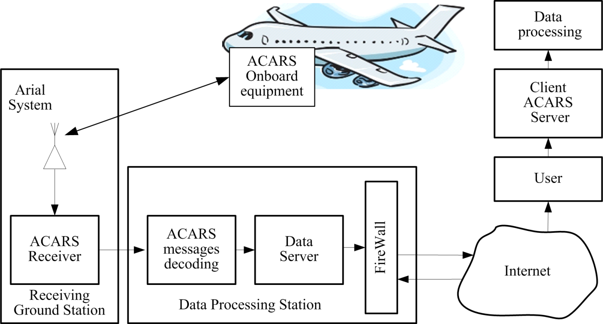

Fig. 1. Typical principle of ACARS tracking

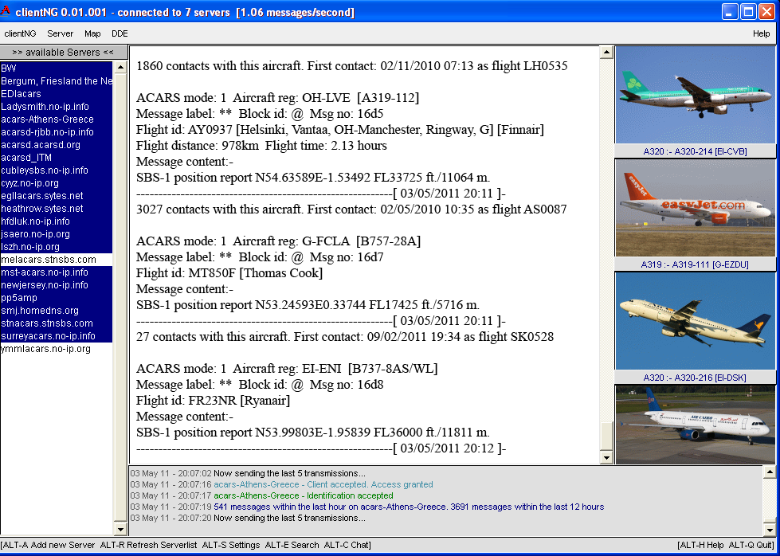
Fig. 2. ClientNG software

Every ACARS message that was collected by client of ACARS data server is saved in “log-file” each second. Thus as the amount of data is increasing, the size of “log-file” is increasing too. The data from “log-file” are available for other software. Data of “log-file” are stored in the decoded format and are represented as text data.
Data Processing
For statistical data processing, monitoring and tracking using ACARS data the special software is used. For example one can use MATLAB software. It allows loading data from “log-file” of ACARS Client.
Let’s consider an algorithm of aircraft tracking by ACARS message (fig. 3).
At the first step the data from “log-file” is loaded to the program memory in the symbolic form of representation. There are a lot of ACARS messages from different aircraft among which there are some that contain the position reports. Therefore it is necessary to select only those that contain the position data. The rest of them will be lost. ACARS messages can have the different structure chosen by airlines but the structure of position report usually looks like the same. This similarity of the position reports gives the possibility to decode the aircraft coordinates and its flight level. The common position report consists of:
– Type of message;
– Latitude;
– Longitude;
– Flight level.
Using MATLAB software one can decode ACARS messages and select an aircraft coordinates and flight level from the position report. After obtaining this kind of data it becomes possible to depict aircraft position on the map. The necessary area of the map is loaded from of the free map servers (Google or Yandex). An area of the map is chosen in such a way that all the aircraft position marks are located inside this area with some distance from the boarders. Of course it is necessary to convert the aircraft coordinates format into the required map format.
For visualization it is necessary to label each of aircraft with special microlabel that contains the aircraft registration number and flight level. In such a way each of the data from the position report is marked on the map. The data updating appears in on-line regime.
The results of this calculation and visualization are represented on the fig.4-6.

Fig. 3. The common operational principle

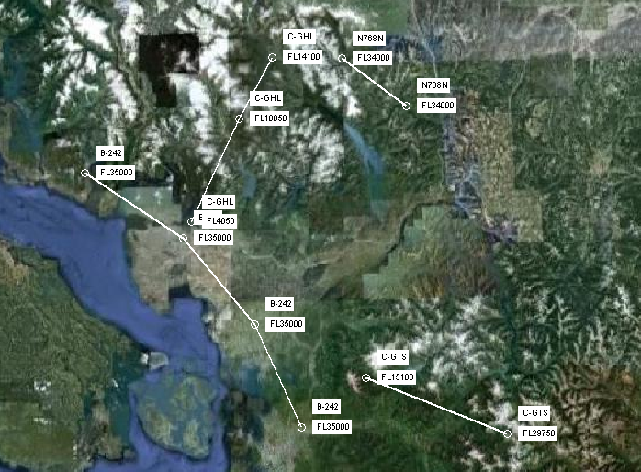
Fig. 4. Visualization of aircraft tracking with trajectories of flight
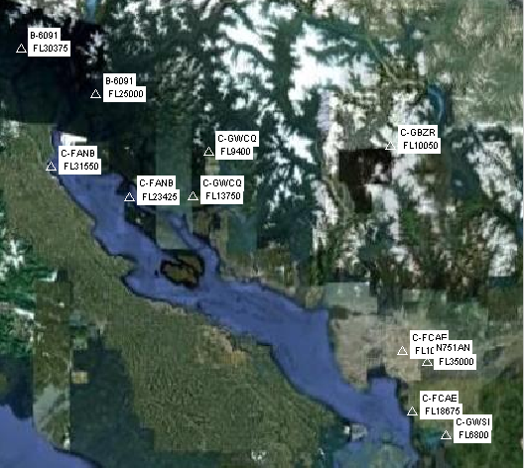  Fig. 5. Visualization of aircraft tracking | 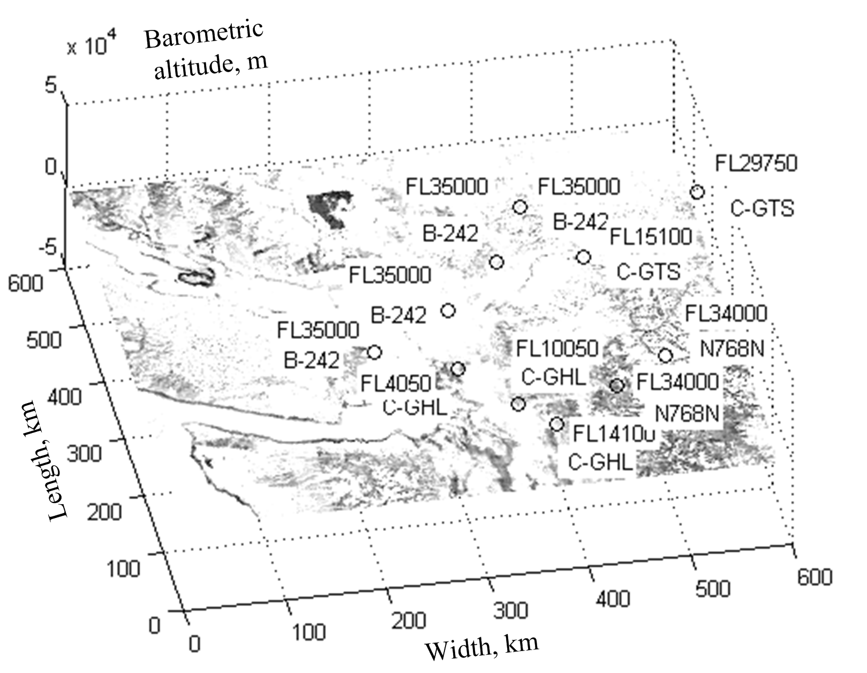  Fig. 6. 3-D visualization of aircraft tracking

The picture shows the aircraft in the Vancouver air traffic region of the Western Canada area. ACARS data were obtained from airport servers of Vancouver and it vicinity. All these data are not secured and are free for any uses. Investigation was done at 7.00 p.m. of 30.11.2010.
This investigation can be applied for any air traffic region around the world. Because, the common operational principle is still the same. The difference is only in the source of data (ACARS data servers).
Conclusion
Digital transmission from the aircraft to the ground provides the possibility to track an air traffic around the world. ACARS is the first representative of them. The represented scheme of transfering the data from on-board equipment to the ground and any point of the Earth is useful for aircraft tracking all over around the world.
The proposed operational principle of aircraft tracking software allows data processing from ACARS and its representing in a simple way for understanding.
The final depiction shows the exact aircrafts position, gives the possibility for continuous tracking and investigation of airflow capacity at the given area. An aircraft tracking is very important for safety of flight in real time.
Currently ACARS system is outmoded facility. And the VHF digital high-speed data link (VDL) of 1, 2, 3, 4 modes are developing quickly. But not all of the aircraft are equipped with them. Thus ACARS systems give more information about air traffic because many aircraft possess it.
References
1. Kuz’menko N.S. Information management in air traffic / N.S. Kuz’menko, I.V. Ostroumov // Problems of navigation and Air traffic management: International Scientific-Practical Conference of Researches and Students, November 23 – 24, 2010 : theses. – К., 2010. – 33 p.
2. Moir Ian. Civil avionics systems / Ian Moir, Allan Seabridge // John Wiley & Sons, 2006. – 396 p.
3. Official web site of FlightAwere corporation: http://flightaware.com.
4. Official web site of Fly Smarter: www.flightstats.com.
5. Official web-site of ACARS decoder: http://www.acarsd.org.
6. Stacey Dale. Aeronautical radio communication systems and networks / Dale Stacey // John Wiley and Sons, 2008. – Technology & Engineering. – 350 p.
7. Sudarshan H.V. Seamless sky / Hindupur V. Sudarshan // Ashgate Publishing, Ltd.,
2003. – Transportation. – 395 p.
8. Tooley Mike. Aircraft digital electronic and computer systems: principles, operation and maintenance / Mike Tooley, Michael H. Tooley // Butterworth-Heinemann, 2007. – Technology & Engineering. – 198 р.
9. Watch aircraft live. Official web site: http://www.flightradar24.com.

The editors received the article on 23 Febryary 2011.

