FRICTION PAIR TRIBOLOGICAL PROPERTIES IN MAGNETIC FIELD

M. Svirid, PhD Engineering, associated professor (National Aviation University, Ukraine)
I. Trofimov, PhD Engineering, associated professor(National Aviation University, Ukraine)
A. Plotnykov, student faculty of flying aparatov (National Aviation University, Ukraine)
A. Kolomiiets, student a department chemical thecnology (National Aviation University, Ukraine)

In the article the processes, going during friction in the unidirected magnetic field and in the impulsive magnetic field are considered, frequency of impulses is regulated.
Optimal parameters for friction pair renewal are determined. Investigation of paramagnetic material tin was carried out in different MF-s: a constant magnetic field; 1-pulsed unidirectional, 2 - 6 Hz pulse modulated.

During machines and mechanisms exploitation they lose the working capacity, and wear is one of the primary factors, negatively influences on friction knots work. Machines service life increasing straightly depends on the effective and rational using tribopairs, that shows up in support of it calculation parameters and such cases gathers over 80%. In many cases details of weighing in a few kilograms change a size from several to 300 microns, pass to the state of unserviceable, but the main it’s part is fully working.
There are many methods of friction pairs renewal: galvanic, plasma, detonation, electrochemical. In the given work the method of renewal with the help of magnetic field is considered.
Thus, the most perspective way of mechanism capacity support will be it’s renewal and it is desirable in the conditions of without disassembly of the unit technologies
The effectiveness of the technique rational and constructive tribological friction units manifested as far as replacing old equipment. Thus, the most promising will increase wear resistance by acting on the surface of the friction constant magnetic field using additives to lubricants.
Research of authors [1] have shown that at passing of magnetic lines through contact zone wear resistance of steel surfaces increases.
Also work is known [2] where it is experimentally proved that the electromagnetic field promotes selective carrying.
Also recently magnetic impulse processing is widely applied for reliability of cutting tool work.
Increasing of mechanical and tribological properties of tool steels after processing by impulse magnetic field [3] is known.
Large attention was always spared for operating reliability and problem of machines and mechanisms longevity. An increase of wearproofness is an actual task that can be decided on the base of deep scientifically-reasonable decisions.
Repair and renewal of precessions pairs working details of pumps differ in high labour intensiveness, exactness of details making, that in a turn affects an a price. The prospective knot is a cylinder-piston by hard requirements on admittances to 3-5 microns.
Technical progress complicates the machines work terms, the specific loadings and tribopairs exploitation terms increase [1], moreover aspiration to decrease weight of aggregate is important task.
Process of exploitation requires the increase of tribopair work, extension of resource due to the choice of rational method of renewal. Relevant technology becomes recovery- place machine parts that decreases the price of machines life resource.
The work purpose: to investigate condition of tribological system in unidirectional MF and impulse unidirectional magnetic fields. To define conditions of working capacity and renewal parameters of friction pair.
The tasks of this work are:
- determination of the magnetic field influence on friction surfaces.
Object - the study of the processes of friction on zone under the influence magnetic fields.
The subject of the research is to determine the patterns of influence between the MF and the transformation of the surface material in friction. (processes of interaction of physical objects)
Thus, perspective direction of renewal in the exploitation process problem decision is the most not studied way of the magnetic-field energy using for the change of the system state to the reparation level.
Taking into account, that lubricating materials are component part of tribosystem, the study of friction knot tribological parameters becomes perspective by the magnetic field influencing the on oil.
So, as tribomagnetic renewal technologies include for itself intercommunication of working environment, oil with working materials (products of wear, oil modificators), then in the process of friction micromagnit processes will be realized in the wear products particles, that magnetize and design properties of magnetic liquid that consists of oil and wear products.
Work mechanism of magnetic liquids, that consist of magnetized metallic powder small particles, the nearest represents the friction knot work conditions in lubricating environments and surfaces wear processes under the action of force magnetic lines. [1-3]
Materials and methodic of experiment carrying out.
Researches were conducted with the help of tribological complex [4] (finger-plane scheme friction circumferentially) with the speeds 0,5m/s, 1 m/s and 1,5 m/s, loading changed from 0,1 to 5 MPa. ШХ15 served as a standard and ЛС59-1 – as a rider, working environment: М10Г2_{к} (mineral) and 5W40 (synthetic) motor oils. For quicklier study of paramagnetic material influence mechanism on the friction conditions of ferromagnetic standard on a diamagnetic rider oil modificator, tin paramagnetic powder was used.
Tribologichni parameters of ШХ15 steel ferromagnetic on diamagnetic ЛС59-1 in the environments of М10Г2к and 5W40 with tin paramagnetic powder addition under the magnetic field action are presented on fig 1.
Fig. 1. Tribological parameters of feromagnetic ШХ15 steel on diamagnetic ЛС59-1 in the environments a) М10Г2к and b)5W40 with tin paramagnetic powder addition under the magnetic field action due to the load
During use of force lines direction in accordance with S-S-N-N direction, paramagnetic tin comes out from the magnetic field action area in a working environment, thus, the products amount for protective tapes formation is greater (fig. 2d) and 2h), accordingly the renewal level is higher (fig. 1).
On fig. 1d) and 1h) the friction surfaces are shown at magnetic field S-S-N-N direction and magnetic induction 0,3 T, that more intensive covered by the protective tapes.
Reason of it is that according to this magnetic field direction tin partly came out from the magnetic field action zone in an oil environment.
Then tin gets on the friction surface where accepts active part in creation of protective tapes. Thus, it is needed to notice that renewal level is higher and equal 1,5…3,5 mkm/km (fig.2).
However, if to talk about quality of protective tapes, it is evident that when magnetic field influences on a working environment, protective tape, which creates on the friction surface more thin, but it’s tribological quality is better (fig. 1b and 1f): 1,5..2mkm), it is more elastic and has a higher level of capacity than without magnetic field influence, which thicker (fig. 1a) and 1e): 4…6 mkm), but peels very quickly, as is not elastic, thus, owning the low level of capacity.

М10Г2к
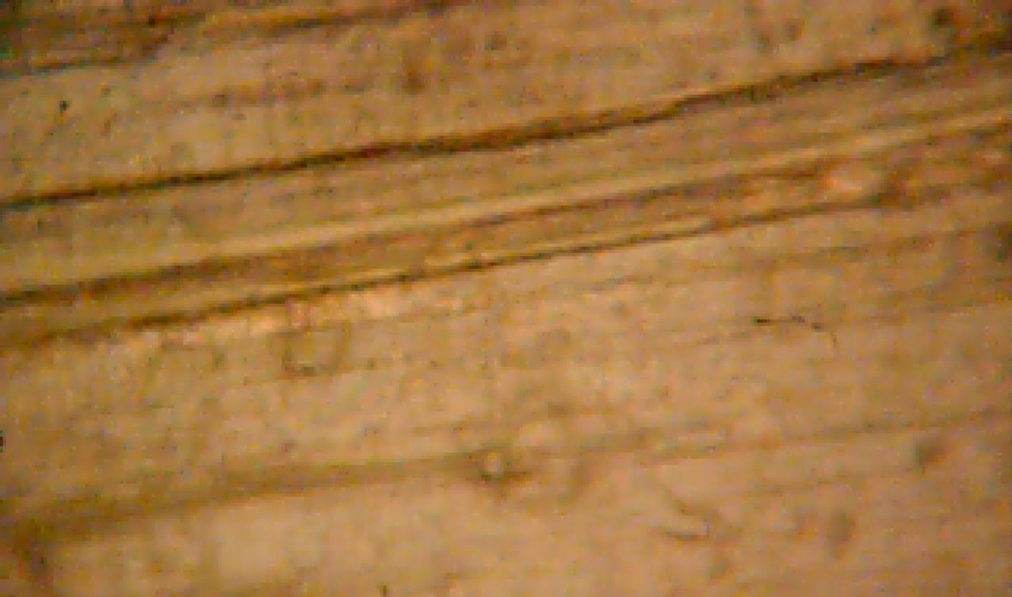  а) |   b) | 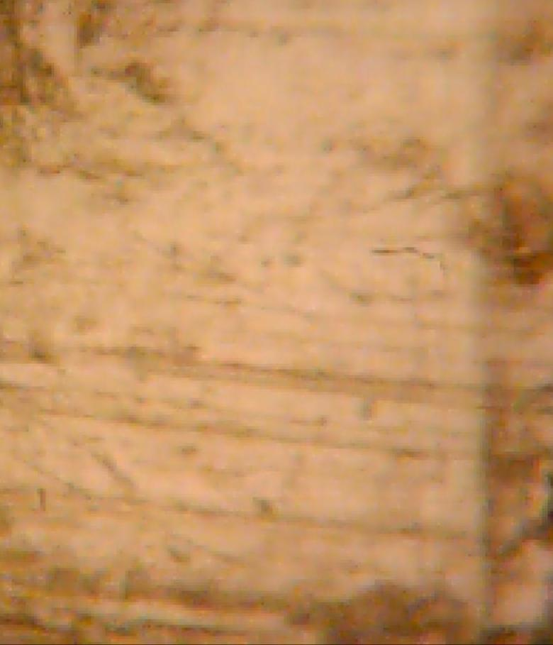  c) |   d)
5W40
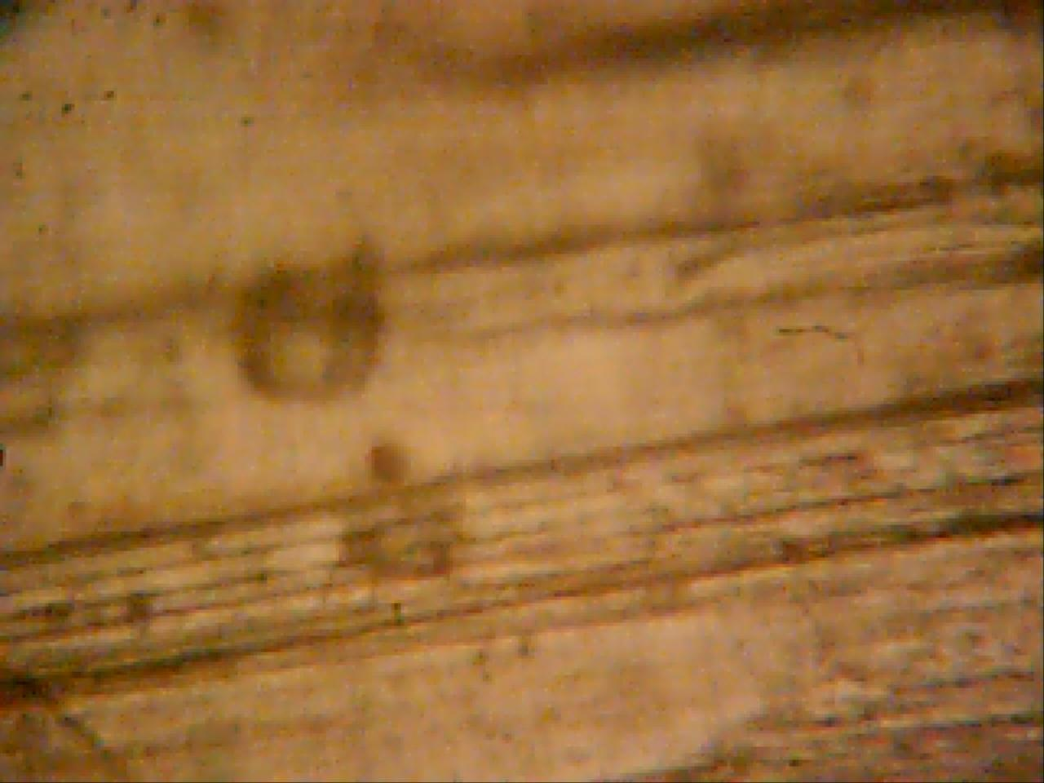  e) |   f) |   g) |   h)
Without magnetic field | S-N | S-N- S-N | S- S -N-N
Fig. 2. ШХ15 standards friction surfaces topography on the rider ЛС59-1 in treated by the magnetic field environments of М10Г2к and 5W40 with tin powder addition with different direction of magnetic lines and size of magnetic induction
In the process of experiment in friction zone modifying powder was added, powder of paramagnetic class – tin (Sn – fraction to 20 microns).
The next stage of research conducted at the facility with reciprocating, scheme finger plane.
For research specimens from steel 65Г, tempered on martensite are used, for rider used copper alloy ЛС59-1. As the working environment mineral oil М10Г2к served, in friction zone paramagnetic powder of tin was added.
Researches were conducted at speed 0,12 km/s, normal loading 3,5 МPа and magnetic induction 0,19 Tl on tribological installation [4]. Installation consists of the power supply, oscillograph, the breaker, the ampermeter for current registration in friction zone, the ampermeter for registration of current passing through the coil of inductance, the coil of inductance, capacities for working environment, loadings element, friction knot.
At direction S/N magnetic power lines are directed in the specimen, and paramagnetic is involved in a magnetic field, hardness Sn (5НВ) it is much less, than steel 65Г (66НВ) and brass ЛС59-1 (30НВ), therefore working specimen surface is renewed (fig. 3 – 1).
At MF N/S direction (fig. 3 – 3, 4) process of recovery of both friction surfaces is explained by common action of deformation component and the positive gradient direction MF. Without MF total wear is maximum, and plus on working specimen is explained be mechanical component of friction (fig. 3 – 5, 6).
Fig. 3. The dependence diagram of tribological characteristics in a uniform magnetic field in the environment of М10Г2к

Fig. 4. The electric scheme of installation connection: 1 – arrangement of the breaker for creation of MF with N/S direction, 2 – arrangement of the breaker for creation of MF with S/N direction.

For creation of impulse magnetic field to the electromagnetic coil connected the breaker, depending on magnetic field direction its location concerning the coil has to be changed, fig. 4 position 1 or 2.
It is known that paramagnetic by the action of magnetic field is displaced in the area of magnetic lines positive gradient. So, tin, which is paramagnetic, powder using, for tribomagnetic renewal of ШХ15 steel and 65G friction surface by adding of this powder to the working environment, namely in М10Г2к and 5W40 oils, and wear researches during different directions of magnetic lines [5] and different magnetic induction size enable by quicklier method to define system tribological parameters.
According to the tasks researches conducted at different magnetic field directions in accordance with which on fig. 1. the friction surfaces topographies are got with the tribological complex using [4].
Proof of it are researches on «micron-alpha» device, noncontact 3d profilograf [6], that show surfaces topography and tapes thickness analysis during renewal with the paramagnetic tin using without magnetic field action (fig.5a) and during SN><SN magnetic field direction (fig. 5b).

a) b)
Fig. 5. ШХ15 steel friction surface profilography on diamagnetic ЛС59-1 1 in М10Г2к environment with tin paramagnetic powder addition a) without magnetic field, b) S-N- S-N magnetic field direction
Conclusions:
1. It is determined, that when magnetic field acts on the working environment, surface film , which appears on the friction surface has higher level of capacity than at a friction without magnetic field influence.
2. It is set, that in the case with paramagnetic tin powder in oil composition, at the magnetic field influence on a working environment at the friction, the greatest renewal level is at S-S-N-N magnetic field direction and equals 1,5…3,5 mkm/km.
3. Influence of unidirected magnetic field and unidirected impulsive magnetic field is considered due to tribological characteristics of friction pair, also determined, that surfaces are the most capable in the conditions of the straightened signal of electric current, which creates impulsive magnetic field. Due to these parameters of outsourcing there are the tribological tapes, with small quantity of oxygen, it characterizes formation of servo tapes.
4. It is determined that during the straightened signal of MF and impulsive breaking with frequency 6,25 Hz tribosystem is restored, with using the elements of renewal powder and working environment.
5. It is established that the arrangement of friction surface on S/N pole during reversive movement of specimens is a preferable direction of MF for renewal.
Literature:
1. Трибология. Исследования и предложения: Опыт США и стран СНГ/Под ред. В.А. Белого, К. Лудемы, Н.К. Мышкина. - М.: Нью-Йорк, 1993.
2. Белый А.В., Карпенко Г.Д., Мышкин К.Н. Структура и методы формирования износостойких поверхностных слоев. - М.: Машиностроение, 1991. 45с.
3. Розман Г.А. Строение и свойства вещества (учебное пособие), Изд. 2-е, переработанное. Псков, изд-во ПГПИ, 2001. - 292 с., рис. 131, табл 12.
4.Свирид М.М., Паращанов В.Г., Занько С.М., Задніпровська С.М., Приймак Л.Б., патент на корисну модель: Пристрій для дослідження матеріалів на тертя та зношування, UA 36600 GO1N 3/56, 27.10.2008.
5. Свирид М.Н., Кудрин А.П., Приймак Л.Б. Трибологические параметры сталей в обработанных магнитным полем смазывающих материалах. - ХНУ, Проблеми трибології. 2012. – №1 – С. 22-24.
6. Игнатович С.Р., Закиев И.М., Борисов Д.И., Закиев В.И., Методика исследования физико-механичесеих свойств поверхностных слоїв материалов при усталости с использованием многофункционального прибора «Микрограмма» / Авиац.-косм. Техника и технология: - Х.: ХАИ. – Вып.8(16).- 2004.-С.103-166.
7. Макаренко А.С., Евдокимов В.Д. Влияние электромагнитного поля, проходящего через зону фрикционного контакта, на знос при высокоскоростном трении // Проблеми техніки: Науково-виробничий журнал. Одеса: Диол.-Принт, 2005. – № 1. – С. 77–84.
8. Евдокимов В.Д., Макаренко А.С. Влияние магнитного поля на избирательный перенос при трении // Проблеми техніки: Науково-виробничий журнал. – Одеса: Диол.-Принт, 2006. – № 4. – С. 70–783. В.И. Альлшиц, Е.В. Даринская, О.Л. Казакова, ЖЭТФ 111, 615 (1997).
9. М.Т. Галей и др. Изучение влияния магнитного поля на стойкость быстрорежущего инструмента // Станки и инструмент. 1981. – № 4. – С. 31-32.
10. Патент на корисну модель № 45574, МПК G01N 3/56. Пристрій для дослідження матеріалів на тертя та зношування при зворотно-поступальному русі / Свирид М.М., Кудрін А.П., Задніпровська С.М., Ловейко М.Г., Морозова І.В. Заявёлено 29.07.2009; Опубл. 10.11.2009, Бюл. № 21
11. Ю.А. Осипьян, Ю.И. Головин, Д.В. Лопатин, Р.Б. Моргунов, Р.К. Николаев, С.З. Шмурак. Влияние импульсного магнитного поля на микротвердость монокристаллов С_{60.} // Письма в ЖЕТФ, том 69, вып.2, стр. 1999г. с.110-113.
12. Galligan J.M., Lin T.H., Pang CS. Phis. Rev.Lett., 1977, v. 38, № 8, p. 405-407.

