MINISTRY OF EDUCATION AND SCIENCE OF UKRAINE

National Aviation University

Materials science

Methodical recommendations
on doing homework
for students of Field of Study 27 "Transport",
Speciality 272 “Aviation transport”

Kyiv 2018

УДК
ББК

Author: O.V. Tisov

Rewieved by: _____________________________ “____” _________________ 2015

Approved by engineering department of AEROSPACE INSTITUTE OF NATIONAL AVIATION UNIVERSITY (PROTOCOL № of y.)

Методичні рекомендації включають вимоги до виконання домашнього завдання з дисципліни “Матеріалознавство“ і індивідуальні завдання з описом змісту для кожної теми.
Для студентів напрямів підготовки 272 “Авіаційний транспорт”.

Methodical recommendations include requirements for carrying out the home task on the subject “Materials science“ and the individual tasks with description of the contents of each topic.
These recommendations are intended for students of Speciality 272 “Aviation transport”
Contents
Introduction | 4
1. Objectives, structure and requirements to home task | 5
1.1. Purpose of home work (HW). | 5
1.2. General requirements | 5
1.3. Requirements for The structure of HW | 5
2. Home work Preparation | 6
2.1. General | 6
2.2. Style of paper | 6
2.3. Format of text | 6
3. Estimation and grades | 8
4. Recommended literature | 9
Topics for home task №1 | 11
Appendix1. Title page | 15
Appendix 2. Contents | 16
Appendix 3. Page example | 17

Introduction

The home task on “Materials science” is one of the basic kinds of students’ individual work. Doing this task students learn to analyze material acquired at lectures and laboratory classes. One of the most important tasks is working with internet issues and literature in library.
Homework is performed in the second semester, according to approved in the prescribed manner guidelines, with a deep study of theoreticamateriall knowledge and skills of students and is
important step in learning what is taught in second semester. Homework is done on the basis of educational material, given to an independent study students, and is part of the module №2 “Alloy steels and nonferrous alloys. Nonmetallic and composite materials” Execution of homework is done by student individually according to methodical recommendations, developed by the department. The time needed for homework - 8 hours.

1. OBJECTIVES, STRUCTURE AND REQUIREMENTS TO HOME TASK

1.1. Purpose of home work (HW).
The home work is directed on in-depth study of that part of material on the subject "Materials science", which concerns the self-study topics of the second module. They should learn to work with the a number of related issues. Thus, during the execution of WH students can acquire practical skills on the selection of appropriate literature and making short abstracts of it.
Doing home task is aimed at forming knowledge, skills and experience for deciding engineering tasks, which are connected with structural and special material application in design, manufacturing, maintaining and restoring of ground vehicles, road machine and ground installations, aircraft and special equipment

1.2. General requirements.
Home task should contain the following items:
- Summary, which is short explanation of obtained results of just a description of the work. This will help to estimate the individual contribution and depth of analyzing the task of HW;
- List of contents;
- Introduction (the state-of the-art);
- Solution (description) of the task, according to approved contents. Student may add some items, but can not omit any of approved subtitles of HW;
- Conclusions on the topic of HW;
- list of references.

1.3. Requirements for The structure of HW.
Title page is made in accordance with appendix 1. It is followed by summary, on a separate page. This is page #2. The third page is contents, which shows the titles (first, second and other orders) of HW parts and the pages on which they begin (appendix 2). The fourth page – is introduction. Introduction is followed by the main part of HW material, which is split into parts according to contents. The last page of the HW is a list of references used in it. There should be 10-15 references. The language of the HW is English.
Home work is printed only on 1 side of standard A4 sheet. All sheets should obviously be stapled or crimped. The usage of paper clip is not allowed. Also pages should be numbered at lower right corner of the page (accept of the first one). Detailed requirements are listed in part 2 of current recommendations.
2. HOME WORK PREPARATION

2.1. General.

LANGUAGE The language is English; all papers must be submitted in that language. The Google-translation variant of language will not be accepted.

LENGTH OF HW Do not exceed twenty pages in total, including all diagrams and pictures. The diagrams and pictures should be included into text correctly, according to requirements. Also, HW should not be shorter then 15 pages

SUMMARY A 100-200 word summary should be included at the beginning of the home work. It is given already after the list of contents, on a separate page. No other text is added to page with summary. It should explain the main concepts, ideas and solution methods of the task/problem.

2.2. STYLE OF PAPER

Paper Format: The paper format must be Din A4 (21 x 29.7 cm; 8.2 x 11.6 inch) with margins as mentioned below:
- top margin: 2.5 cm (0.98 inch)
- left margin: 2.5 cm (0.98 inch)
- right margin: 2.5 cm (0.98 inch)
- bottom margin: 2.5 cm (0.98 inch)
Text must be typed within the spacing noted above, leaving exact spacing desired for diagrams, tables, charts, photos, etc. During reproduction for printing, each page will be photo reduced to 3/4 of original size. Recommended typing spacing within the image area is 36 lines per page (line spacing 1.5), 65 characters (including spaces, 10 characters/inch) per line. For diagrams, remember that reduction will make print smaller.

Font type and size:
Font type for all headings and text is Arial.
- Font size Main-Header: 14 pt bold
- Font size Text: 14 pt
- Row-Spacing: 1,5 Row

2.3. FORMAT OF TEXT
Title:
ALL CAPITAL LETTERS
bold-faced, flush with left-hand margin. Title should begin on line 1.
First-order headings in text: ALL CAPITALS, flush left
Second-order: Initial Caps and Lowercase, flush left
Third-order: Initial Caps and Lowercase, indent 8 spaces (1 tab)

References: should be numbered in order of mention in the text, and listed at the end of the paper under a first-order heading LIST OF REFERENCES. Designation in the text should be as: (ref. 1) i.e. in parentheses. Do not include textual material in references; footnote such material instead. Likewise, do not include references in Tables or footnotes, but rather in the list of references. Use only references that are available to the general public. Reference should be composed as follows:
Patent: Pat. 84998 Ukraine С21D1/78 (2006.01) A method of producing wear resistant gradient plasma coating with high running in properties / Kindrachuk M.V., Korbut, E.M., Stebeletska N.M. and others., № u 201304817; Appl. 16.04.2013; Publish. 11.11.2013, Bull. Number 21. – 4p. (In Ukrainian)
Article Tubielewicz Krzysztof. Influence of wear during friction of chosen properties of a steel surface after burnishing process / Krzysztof Tubielewicz, Andrzej Zaborski, Wladyslaw Skoneczny // Tribologia. – 2003. – V. 22, №2. – P. 13 – 19.
Book: Chichinadze AV. calculation, testing and selection of friction pairs / A.V. Chichinadze, E.D. Brown, A.G. Ginsburg, Z.V. Ignatiev. Moscow: Nauka, 1989. – 267p. (In Russian).
Web: Title of source. [Web source] : – Kyiv, Ukraine international airlines. Mode of access: http://www.nbuv.gov.ua/articles/2003/03klinko.htm.
If the language of a document is other then English, then it is necessary to indicate this in parentheses.

TABLES: Tables should be numbered consecutively using Arabic numerals and placed flush right; the Table title should use Initial Caps and Lowercase placed flush left 2 x 1,5 lines below. Table footnotes should be indicated with lowercase letters.

FIGURES: Number figures in the order of their mention and provide legends for all figures and titles for all tables. A scale/ruler in the photograph may be useful. Be sure letter or number height on charts is large enough to be legible (ca. 3-4 mm for charts, 2 mm for pictures).

SYMBOLS AND ABBREVIATIONS: Define symbols and abbreviations the first time they are used, or make a list of "Symbols and Abbreviations" to be placed at the end of the paper, before the references.

PAGE NUMBERING: The page number should be placed on the bottom of the page, right hand flush.

3. ESTIMATION AND GRADES.
When estimating the home task the attention should be paid to the following two components:
- The level of knowledge:
The strength and depth of knowledge;
The level of thinking;
The ability to organize knowledge on certain topics;
The ability to draw up a comprehensive plan of response;
To give precise formulation;
The right to use the conceptual apparatus;
Culture of the answer (literacy, logic and sequence of presentation);

- The skills of independent work:
The ability to find the necessary literature;
Orientation in the flow of information on the chosen specialty;
Record keeping skills (drawing up simple and comprehensive plan, outline, lecture, performance, skills and scientific research work).

A grade is a quantitative measuring unit of students’ learning outcomes assessment, based on a multi-value scale as they perform their pre-assigned set of academic tasks.
The ECTS grading system is a system of measuring the quality of all types of classroom and self-study work done by students as well as the level of their knowledge and skills by assessing them in values according to the 100-value scale with further transfer of these values into the national scale and the ECTS scale.
The grading system envisages the use of the following grades: the current module grade, the module test grade, the total module grade, the semester module grade, the examination grade and the total semester grade.
Table 1.

Grade correspondence between grade values
and the National test scale

Carrying out and defense of home work | National Scale
12-13 | Excellent
10-11 | Good
8-9 | Satisfactory
Under 8 | Bad
A student is considered to have passed the homework if both his/her grade is positive, i.e. higher than ‘bad’ according to the national scale.
If a student has not got a positive Homework Grade he (she) must have repeating test in accordance with the established procedure
A student is not allowed to increase his/her positive Grade by taking a repetitive test.

4. RECOMMENDED LITERATURE

- Бялік О. М. та інші. Матеріалознавство: підручник/О. М. Бялік, В. С. Черненко, В. М. Писаренко, Ю. М. Москаленко. – К.: ИВЦ “Політехніка” 2001 – 375 с.
- Пахолюк А. П., Пахолюк О. А.. Основи матеріалознавства і конструкційні матеріали. – Львів: Світ, 2005 – 172 с.
- Абраимов Н. В., Елисеев Ю. С., Хримов В. В. Авиационное материаловедение и технология обработки материалов. Учебное пособие для авиационных вузов. – М.: Высшая школа, 1988 – 444 с.
- Лахтин Ю. М., Леонтьев В. П. Материаловедение. – М.: Машиностроение. 1990 – 528с.
- Лабунец В. Ф. Авиационные конструкционные материалы с высокой удельной прочностью: Учебное пособие. – Киев: КМУТА, 1993 – 116с.
- Дубинин Г. Н., Тананов А. И. Авиационное материаловедение. Учебник для высших учебных заведений гражданской авиации. – М.: Машиностроение. 1988 – 320с

Additional recommended sources
- Groover Mikell. Fundamentals of modern manufacturing. Materials, processes and systems. - USA, John Willey and sons, Inc, 2007. – 1022p.
- S.L. Kakani, Amit Kakani. Materials science. - New Age International (P) Ltd., Publishers, 2004. – 640p.
- Heat Treatment - Conventional and Novel Applications [http://www.intechopen.com /books/heat-treatment-conventional-and-novel-applications] Edited by Frank Czerwinski. Publisher: InTech,2012. – 420p.
- William D. Callister, jr. Materials Science and Engineering. USA, John Willey and sons, Inc, 2007. – 721p.
- Advances in Composite Materials - Analysis of Natural and Man-Made Materials [http://www.intechopen.com/books/advances-in-composite-materials-analysis-of-natural-and-man-made-materials] Edited by Pavla Těšinova. Publisher: InTech, 2011. – 584p.
- Gas Turbines - Materials, Modeling and Performance [http://www.intechopen.com/books/gas-turbines-materials-modeling-and-performance] Edited by Gurrappa Injeti. Publisher: InTech, 2015. – 170p
- Progress in Gas Turbine Performance[http://www.intechopen.com /books/progress-in-gas-turbine-performance] Edited by Ernesto Benini. Publisher: InTech, 2013. – 268p
- Corrosion Resistance [http://www.intechopen.com/books/corrosion-resistance] Edited by Hong Shih. Publisher: InTech, 2012. – 482p.
- Other literature is available online: [http://www.intechopen.com /search?q=materials]

Topics
for students homework on Materials Science

- Heat treatment of high strength aluminium-based alloys (Alloys description. Their mechanical properties. Heat treatment concept. Technology of heat treatment of high strength aluminium alloys. Application for aircraft manufacturing)
- Application of cast aluminium alloys for aircraft manufacturing (Requirements to cast alloys. Alloying elements. Heat treatable and non-heat treatable cast alloys. Chemical composition. Influence of elements on properties of Al-alloys. Grades of alloys and examples of application. Alloy A.356.0; Alloy A357.0.
- Application of wrought aluminium alloys for aircraft manufacturing (Alloying elements. Heat treatment. Chemical composition and mechanical properties (at least 5 grades). Examples of application.
- High temperature alloys for engine hot section elements (Nickel-based alloys. Classification. Alloying elements. Intermetallic compounds. Examples of heat treatment procedure for nickel based alloys. Examples of application)
- Magnesium alloys in aircraft structure (General properties of magnesium. Cast alloys. Wrought alloys. Advantages and disadvantages. Corrosion protection. Grades and mechanical properties (at least 6 grades). Chemical composition)
- Corrosion of aircraft elements (Dangerous areas. Environmental influence. Differential aeration. Differential concentration. Electonegativity influence).
- Corrosion protection of aircraft internal structures (Corrosion types and mechanisms. Dangerous areas. Effect of corrosion over internal structures on flight safety. Barrier protection – paint coatings. Corrosion protection compounds)
- Alloy steels for aircraft GTE (Properties of alloy steels. Heat resistance. High temperature strength. Abrasion resistance. Hot gaseous corrosion protection. Grades of alloy steels used for compressor blades, shaft and discs (at least 7 grades). Mechanical properties)
- Structural application of alloy steels (Properties of alloy steels. Wear resistance. Formability. Low alloy high strength steels (at least 4 grades). Heat treatment. Mechanical properties. Protection from environmental influence – debris, sand and soil, moisture.)
- Handling of aluminium alloy rivets (Alloys used for rivets. Heat treatment in maintenance condition. Time for driving rivets. Rivets cold storage)
- Aramid fibre reinforced composite materials (Structure of aramid fibre. Manufacturing process. Mechanical properties. Types of matrix. Aircraft composite structures. Advantages/disadvantages of these composites)
- Glass fibre composites (Glass fibre manufacturing. Grades of glassfibre: S-grade and E–grade. Mechanical properties of glassfibre. Glassfiber composites application for interior and exterior panels. Advantages and disadvantages)
- Composites in aircraft structure (Advantages of composites. Disadvantages of composites. Environmental stability. Determination of mechanical properties. Tensile strength. Compression. Fracture. Losipescu shear test.
- Carbon fibre reinforced composite materials (Structure of carbon fibre. Manufacturing process. Carbonization. Mechanical properties. Types of matrix. Aircraft composite structures. Advantages/disadvantages of these composites)
- Aircraft thermal insulation (Necessity of thermal insulation. Temperature difference. Fuselage insulation. Materials of insulating mats. Moisture ingress and corrosion danger)
- Aircraft fabrics (Types of fabrics – natural and synthetic. Cotton A-grade. Painting system. Nitride dope. Rejuvenation of nitride dope)
- Selection of aircraft fabric (Determination of fabric type currently used on aircraft. Wing loading. Never exceed speed. Strength of various fabrics (table of mechanical properties), fabric strength testing).
- Biological corrosion of fuel tanks (General corrosion reasons. Mechanisms of corrosion. Corrosion of fuel tanks. Dangerous areas. Fungal attack. Fungal deposits. Water ingress. Protection of fuel tanks from biological corrosion)
- Aircraft wooden structures (History of wood application. Types of wood. Requirements to the quality of aircraft wood. Mechanical properties of aircraft wood. Other important wood properties. Defects of wood. Protection of wood from environmental influence. Airframe application of wood for light aircraft
- α - titanium alloys for aircraft application (General titanium properties. Alloying elements. Microtructure description. Strengthening mechanical and heat treatment. Chemical heat treatment of titanium alloys. Mechanical properties (at least 3 grades))
- Structural application of β – titanium alloys for aircraft (General properties. Alloying elements. Heat treatment. Grades of β – titanium alloys. Mechanical properties and chemical composition (at least 3 grades).
- Titanium alloys – prominent structural material for aircraft (General properties of titanium. Classification of alloys. Wrought, cast alloys. α, β and (α+ β) alloys. α- and β-stabilizers. Influence of alloying elements on mechanical properties. Corrosion resistance.
- Application of Titanium alloys for aircraft structures (General properties of titanium. Classification of alloys. Main grades of α, β and (α+ β) alloys. Hardening of α, β and (α+ β). Alloy Ti-6Al-4V – chemical composition, mechanical properties, heat treatment. Examples of application of the alloy in airframe or engine)
- Alloy steels. Classification and grades (National designation system. SAE designation system. Chemical composition and mechanical properties of aircraft low alloy high strength steels (AISI 4130, 4140, 30ХГСА, 40 ХНМА). Heat treatment procedure).
- Copper-based alloys for aircraft wear application (Classification of copper alloys. Brass. Bronze. Aluminium bronze: chemical composition and heat treatment. Beryllium bronzes. Nickel bronzes. Mechanical properties of bronzes
- Cast aluminium alloys application for piston aeroengines (Operating conditions (temperature, chemistry, mechanical loading). General requirements to engine-applied alloys. Duralumin. Hyduminium. “Y”-alloy. Heat treatment. Corrosion aspect).
- Type 300 stainless steels (Alloy steels – alloying elements, properties. Chromium-Nickel steels 301, 302, 303, 304. Low carbon Cr-Ni-Si-Mo steels (type 316, 316L). Chemical composition. Heat treatment. Corrosion resistance. Mechanical properties. Most prominent steel suppliers)
- Precipitation hardened steels (Precipitation hardening – mechanism of strengthening. Chemical composition (for eg. alloy 17-4PH, 17-7PH, 15-5PH). Mechanical properties. Aircraft application of precipitation hardened steels)
- Aluminium alloys application for aircraft structural elements (Aluminium-making process. Hydrogen impact on mechanical properties. Purification. Degassing of alloys – slow solidification, flux degassing, and rotary degassing. The influence of alloying elements on properties of aluminium alloys)
- Turbine blades and combustion chamber protection materials (Temperature range of operation. Thermal shock. Materials of turbine blades and combuster. Thermal barrier coating. Oxidation barrier. Ambient barrier coating. Ceramic matrix composites with ceramic filament)

Appendix 1
MINISTRY OF EDUCATION AND SCIENCE OF UKRAINE
NATIONAL AVIATION UNIVERSITY
ENGINEERING DEPARTMENT

APPLICATION OF COBALT-BASED ALLOYS FOR GAS-TURBINE ANGINES

Hometask on discipline: Materials science

Student: Peterson Petro
Group: 305 FA

Accepted: ____________

Date “___” ____________ 2018

Grade ____________

Signature_____________________

Kyiv 2018
Appendix 2
Contents

Contents_ _ _ _ _ _ _ _ _ _ _ 2
Abstract_ _ _ _ _ _ _ _ _ _ _ 3
Introduction_ _ _ _ _ _ _ _ _ _ 3
1. Conditions of operation_ _ _ _ _ _ _ _ 4
2. Thermal shock_ _ _ _ _ _ _ _ _ 6
3. Materials used to withstand operational conditions_ __ _ 8
3.1. Metal-based materials_ _ _ _ _ _ _ 8
3.2. Composite materials_ _ _ _ _ _ _ 10
4. Protection methods_ _ _ _ _ _ _ _ 14
5. Conclusions_ _ _ _ _ _ _ _ _ _ 16
6. List of references__ _ _ _ _ _ _ _ _ 17
Appendix 3
1. GRADIENT COMPOSITE COATINGS FOR WORKING SURFACES OF BRAKING DEVICES
1.1. Introduction and formulation of research problems.
1.1.1. Urgency of work
To achieve high and stable friction coefficient the intermediate layer should have specific heterogeneous … material (ref. 1)
Chemical composition of alloys is given in tab. 1.
………………………………………………………………………………
Table 1.
Chemical and phase composition of eutectic alloys
Alloy | Chemical composition, % |  |  |  |  |  |  | Phase composition |  | Hardness, НВ | Melting  point, К
Alloy | Cr | Ni | Ti | V | B | C | Fe | Matrix | Harde-ning elements | Hardness, НВ | Melting  point, К
ВТН | 15,4 | 7,7 | 3,2 | 8,1 | 1,4 | 1,9 | 62,3 | 12Х18Н9Т | TiB₂+  VC | 470 | 1460

Powder alloy P-76 (ref. 4) (fig. 2) is characterized by uniform carbides distribution through the alloy. Grain size varies from 0.5 μm up to 20 μm. Wear chart is shown on fig. 3.

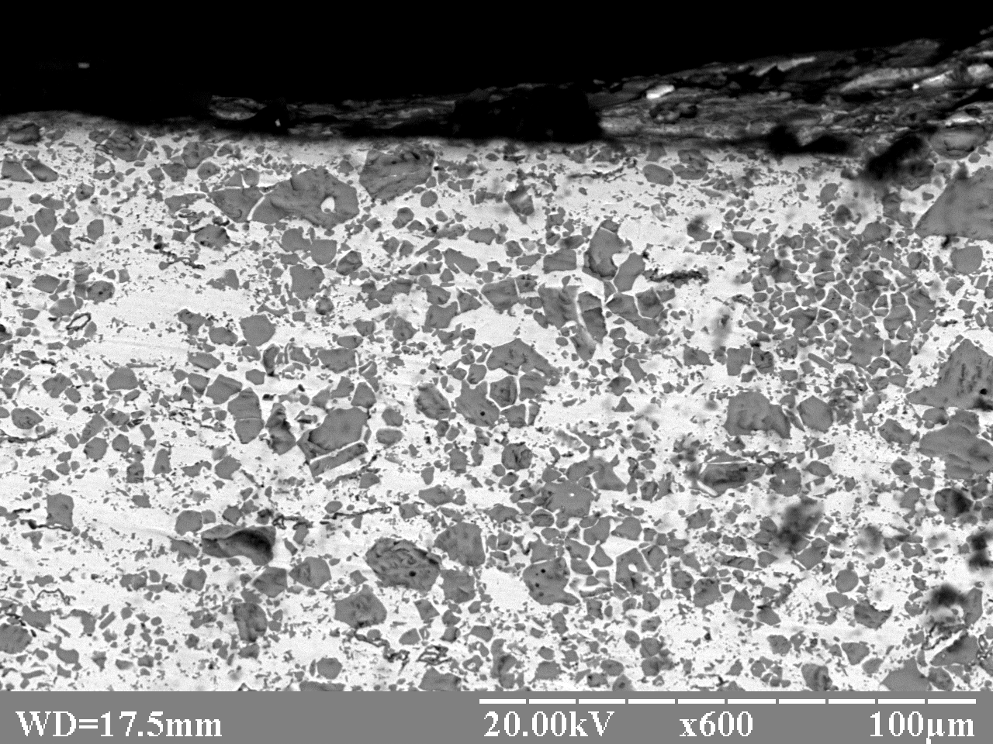 | 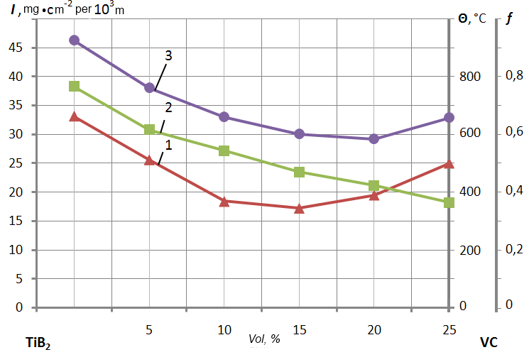
Fig. 2. Microstructure of cast alloys XTH-62 (a), P-69 (b) and cemented Co-TiC carbides (с) | Fig. 3. Dependence tribotechnical properties melted coating VTN plasma volume content of TiB2 and VC at P = 2 MPa, V = 0,5 m / s 1 - f; 2 - Θ; 3 – I

