UDC

**Volodymyr Kharchenko**1

**Katerina Tapia**2

**Oleksandr Shvets**3

**ANALYSING SURFACE MOVEMENT DELAYS IN AN AIRPORT**

1,2National Aviation University

Kosmonavta Komarova avenue 1, Kyiv, Ukraine, 03680

3Ukraine International Airlines

Kharkov highway 201-203, Kiev, Ukraine, 02121

Е – mails: 1[kharch@nau.edu.ua](mailto:kharch@nau.edu.ua); [2](mailto:2)[tapiae@mail.ru](mailto:tapiae@mail.ru); 3[box55@yandex.ru](mailto:box55@yandex.ru)

*Queuing effect can be in the different components of ground operations. Causes of surface – movement delays are long taxi – in and taxi – out operations during departure and arrival of aircraft. Surface movement delays in an airport are analyzed.*

*Эффект очередей может быть в различных компонентах наземных операций. Причинами задержек в наземном движении являются длительные процедуры руления при вылете и прибытии воздушных судов. Анализируются задержки наземного движения в аэропорту.*

*Ефект черг може бути в різних компонентах наземних операцій. Причинами затримок в наземному русі є тривалі процедури рулювання при вильоті і прибутті повітряних кораблів. Аналізуються затримки наземного руху в аеропорту.*

*Keywords: aircraft, capacity, delay, service, queue.*

**Introduction**

Congestion problems are becoming increasingly acute in many airports.

To protect Air Traffic Control (ATC) from overload a planning activity called Air Traffic Flow Management (ATFM) tries to anticipate and prevent overload and limit resulting delays. When the traffic expects to exceed the airport arrival and departure capacities a delay occurs [1]. Delays can be introduced into the system from any overloaded or poorly performing service component. The stages of service that constitute an airport are arranged in a network. This network can be thought of as a single macroscopic server. As for airport the main bottleneck is the runway system, which manifests itself in the following forms: separation requirements between successive departures, capacity limitations based on runway configurations, allocation of runway occupancy to landing aircraft, and capacity limitations of runway crossings. The variable and often relatively high demand due to weather conditions, made it obvious that overloaded runway can explain a majority of the surface – movement delays encountered at airports [4, 6].

Modeling the airport as a ground operation server can show the best course of action to take in reducing delays, determining the value in terms of delays, adding runways or adding equipment so that more aircrafts can use the runways in inclement weather.

**Literature overview**

In [5] mentioned that long queues for departure runways impeded both taxi – in and taxi – out operations, and that taxi operations were impeded by poor visibility.

Departure process

Arrival process

Airport system:

Ground process (gate – turn)

Fig.: 1. Ground – operations pattern.

In [2] presents three models designed to capture the dynamics of ground operations at busy hub airports. Finally, the paper presents possible applications for managing airport congestion by queue delay management.

In [7] presented a new artificial intelligence based taxi – out time prediction technique that adapts to changing airport dynamics. The method is based on the theory of stochastic dynamic programming.

In [3] work is based on extensive analysis of departing aircraft from two airports, it was found that the number of arriving aircraft does, in fact, affect taxi – out times. This impact increases as interaction between departures and arrivals increases, as one might expect.

According to the queuing theory large delays are anticipated as the demand for departures and approaches of the airport. Even larger delays are expected when the demands exceeds capacity. This mismatch often occurs during bad weather conditions: in such scenarios, delays of an airport can rise significantly [8]. Thus queuing effect can be in the different components of ground operations. Causes of surface – movement delays mentioned were:

* taxiways crossing active runways;
* aircraft backing out of gates into taxiways;
* segments of taxiways too narrow for two–way traffic;
* taxiways intersecting [5]

The goal of this paper is to analyse surface movement delays that occur during departure and arrival operations.

**Assessment the impact of aircraft departure and arrival queues on delay.**

At figure 2 traffic enters the arrival queue, , according to a Poisson arrival process with parameter *.* An arriving aircraft enters the taxi–in queue, . After the turnaround delay, ,

the output of the taxi–in queue, , enters the ready–to–depart reservoir, .

Departures enter the queue for aircraft, , according to a Poisson process with rate . Service rate of departure aircraft –*.* When a departure aircraft is assigned, is reduced by 1. The departure aircraft leaves  and enters the queue for taxi–out service, .

The queue for service at a departure runway, , where it is served according to the departure service process with rate . Output from the departure queue, , is output from the airport.

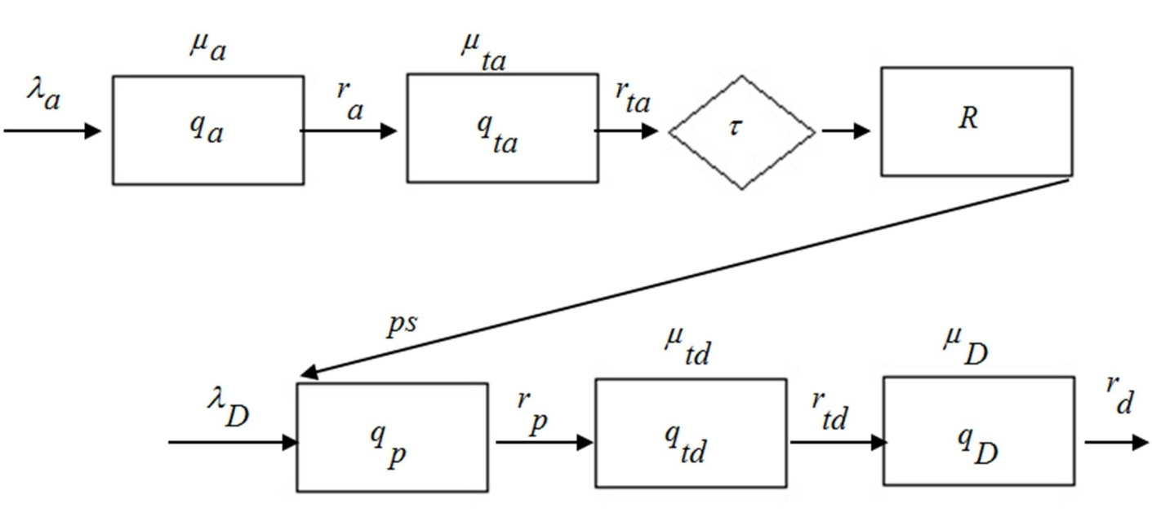

Fig.: 2. Airport queuing network

The first moment of the distribution of the number of clients in the queue:

,

where



*Arrival operations process.*

Conservation of aircraft in the arrival process requires the condition on the process output rate :

**.**

It shows that the rate at which aircraft arrive is equal to the sum of the rate at which aircraft leave the arrival process and the rate–of–change of the arrival queue. That is, arriving aircraft either exit the arrival process or enter the arrival queue.

The output rate, , is the input to the taxi in queue, :

,

and

,

where

.

To conserve aircraft, we impose:

**.**

It implies that the rate of output, , of the arrival process is equal to the rate at which aircraft leave the taxi – in process plus the rate of change of the taxi – in queue, fig. 3:

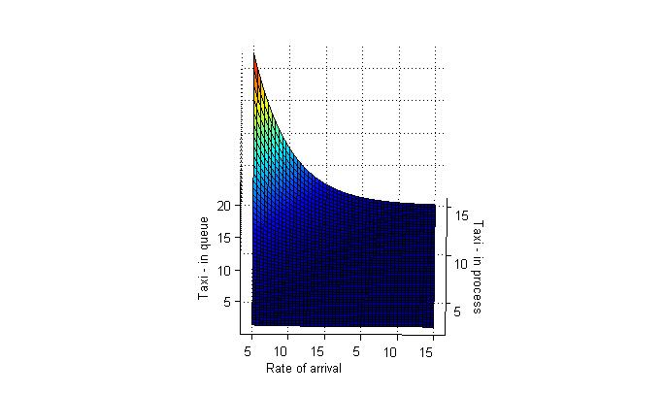

Fig.: 3. Rate of output of the arrival process

Present airport delay, arrivals either exit the entire arrival – taxi – in process or accumulate in either the arrival queue or the taxi –in queue can be shown:

**.**

The output rate of the taxi – in process, , after the turnaround delay, , is the input rate to the reservoir, *R*, of “ready to depart” aircraft. Conservation of aircraft for the reservoir is expressed by

**,**

where – plane service rate.

*Departure operations process.*

A departing flight first queues for service with a “ready to depart” airplane. Our equations for this queue for airplanes are

,

where

,

and  is equal to when , and is zero for nonpositive .

It follows that will remain zero, if .

The departure processes begin with service at the queue for “ready to depart” aircraft. This service depends reservoir, .

If  then cannot be greater than the input rate to the reservoir.

If is not empty, then the service rate,  is large compared to 1. If  is empty, then departing aircraft are supplied by output of the arrival queue, delayed by the turnaround time, .

**.**

To conserve aircraft, we determine the output rate, , of the queue for “ready to depart”: airplanes by

.

The output rate, , is the input to the taxi–out queue, :

 ,

and



By conservation, we determine the output rate, , of the taxi–out queue by

**.**

The output, , of the taxi–out queue is then input for the departure queue, **:

**.**

Finally, for conservation, the output rate of the departure process, fig. 4:

**.**

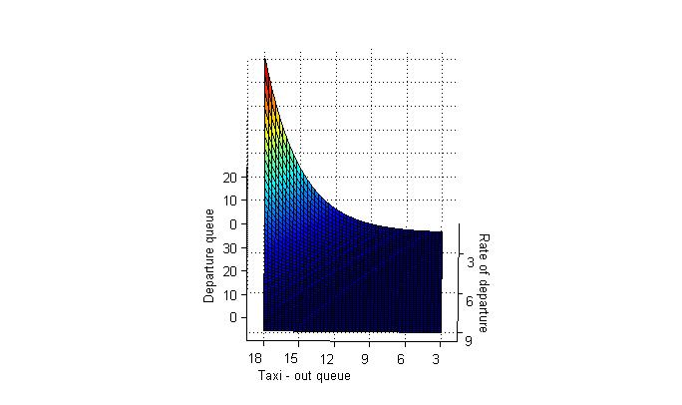

Fig.:4. Rate of the departure process

Analyzing of airport ground operations, fig. 3;4, give us a value of the traffic that should be expected according to arrival and departure ground operations processes.

Before departure and after arrival aircraft pass stages of taxi – out and taxi – in processes that can influence on rate of traffic in airport and, of course, can be the reason of delays. Delays can be introduced into the system from any overloaded or poorly performing service component. If the same runway is being used for both arrivals and departures, the tower controller only allows takeoffs to occur during gaps in the arrival sequence. Thus departing aircraft are often delayed while waiting on the taxiways or at terminals for takeoff clearance. And these aircraft can be delayed for a much time.

**Conclusions**

Traffic demand is input by a schedule of hour-by-hour departures from the network airports and a schedule of arrivals to network airports from terminals outside the network. Large delays are anticipated as the demand for departures and approach the ground operations of the airport. Service of an airport is most sensitive in bad weather conditions and it means that the rate of service can drop significantly. The result of this can be queuing effects in the different components that lead to longer taxi times so even modest increases in traffic will result in substantially increased delays.

**References**

1. *Agustín A.,* Mathematical Optimizationg models for Air Traffic Flow Management: A review / A. Agustín, L. Escudero, C. Pizarro // Dept. of Statistics and Operations Research Universidad Rey Juan Carlos, 2008 — 44 p.
2. *Andersson K.*, Analysis and Modeling of Ground Operations at Hub Airports / K. Andersson, F. Carr, E. Feron // 3rd USA/Europe Air Traffic Management Seminar, 2000. — 15 p.
3. *Clewlow R.,* Impact of Arrivals on Departure Taxi Operations at Airports / R. Clewlow, I. Simaiakis, H. Balakrishnan // *Massachusetts Institute of Technology*, 2006. — 21 p.
4. *Elefante* *S., S*tatistical and probabilistic approach for improving efficiency in Air Traffic Flow Management // Dissertation — Faculty of Engineering at the University of Glasgow, 2001. — 241 p.
5. [*Lee*](http://ieeexplore.ieee.org/search/searchresult.jsp?searchWithin=Authors:.QT.H.%20Lee.QT.&newsearch=partialPref) *H*., A Study of Tradeoffs in Scheduling Terminal–Area Operations /  [H. Lee](http://ieeexplore.ieee.org/search/searchresult.jsp?searchWithin=Authors:.QT.H.%20Lee.QT.&newsearch=partialPref), [H. Balakrishnan](http://ieeexplore.ieee.org/search/searchresult.jsp?searchWithin=Authors:.QT.H.%20Balakrishnan.QT.&newsearch=partialPref) // Department of Aeronautics and Astronautics, Massachusetts Institute of Technology, [2008](http://ieeexplore.ieee.org/xpl/tocresult.jsp?isnumber=4745645). — 12 p.
6. *Long D.,* Modeling Air Traffic Management Technologies With a Queuing Network Model of the National Airspace System / D. Long,D. Lee, J. Johnson, E. Gaier // NASA, 1999. — 121 p.
7. P*.Balakrishna,* Taxi–out Prediction using Approximate Dynamic Programming/ P.Balakrishna, R.Ganesan, L.Sherry // George Mason University, 2007. — 16 p.
8. *Simaiakis I.,* Analysis and Control of Airport Departure Processes to Mitigate Congestion Impacts / I. Simaiakis,H. Balakrishnan // Massachusetts Institute of Technology, 2009. — 29 p.